**CRIMOPEDIA**

*Project Report Submitted by*

**SANGEETHA V SEBASTIAN**

**Reg. No.: AJC20MCA-2063**

*In Partial fulfillment for the Award of the Degree Of*

**MASTER OF COMPUTER APPLICATIONS**

**(MCA)**

**APJ ABDUL KALAM TECHNOLOGICAL UNIVERSITY**



**AMAL JYOTHI COLLEGE OF ENGINEERING KANJIRAPPALLY**

[Affiliated to APJ Abdul Kalam Technological University, Kerala. Approved by AICTE, Accredited by NAAC with ‘A’ grade. Koovappally, Kanjirappally, Kottayam, Kerala – 686518]

# 2020-2022

## DEPARTMENT OF COMPUTER APPLICATIONS

### AMAL JYOTHI COLLEGE OF ENGINEERING

**KANJIRAPPALLY**



**CERTIFICATE**

This is to certify that the Project report, “**CRIMOPEDIA”** is the bona-fide work of **SANGEETHA V SEBASTIAN (Regno: AJC20MCA-2063)** in partial fulfillment of the requirements for the award of the Degree of Master of Computer Applications under APJ Abdul Kalam Technological University during the year 2021-22.

**Ms. Meera Rose Mathew Rev.Fr.Dr. Rubin Thottupurathu Jose**

**Internal Guide Coordinator**

**Rev. Fr. Dr. Rubin Thottupurathu Jose External Exanimar**

**Head of the Department**

**DECLARATION**

I hereby declare that the project report **“CRIMOPEDIA”** is a bonafide work done at Amal Jyothi College of Engineering, towards the partial fulfilment of the requirements for the award of the Master of Computer Applications (MCA) from APJ Abdul Kalam Technological University, during the academic year 2021-2022.

**Date: SANGEETHA V SEBASTIAN**

**KANJIRAPPALLY Reg:. AJC20MCA-2063**

**ACKNOWLEDGEMENT**

First and foremost, I thank God almighty for his eternal love and protection throughout the project. I take this opportunity to express my gratitude to all who helped me in completing this project successfully. It has been said that gratitude is the memory of the heart. I wish to express my sincere gratitude to our manager **Rev. Fr. Dr. Mathew Paikatt** and Principal **Dr. Lillykutty Jacob** for providing good faculty for guidance.

I owe a great depth of gratitude towards our Head of the Department **Rev.Fr.Dr. Rubin Thottupurathu Jose** for helping us. I extend my whole hearted thanks to the project coordinator **Rev.Fr.Dr.Rubin Thottupurathu Jose** for his valuable suggestions and for overwhelming concern and guidance from the beginning to the end of the project. I would also express sincere gratitude to my guide **Ms**. **Meera Rose Mathew** for her inspiration and helping hand.

I thank our beloved teachers for their cooperation and suggestions that helped me throughout the project. I express my thanks to all my friends and classmates for their interest, dedication, and encouragement shown towards the project. I convey my hearty thanks to my family for the moral support, suggestions, and encouragement to make this venture a success.

SANGEETHA V SEBASTIAN

## ABSTRACT

CRIMOPEDIA (Online Crime Reporting System) is a web-based application developed using PHP and MySQL. The aim of the project is that people can report crime online. Presently there is no online web application available to report crime online. In order to report any complaints associated with crime, people have to contact closest police station. Our system makes crime reporting and follow-up easier. Counseling is required for some individuals on the basis of each case. Thus, counseling is requested by police officers for those who need counseling. Counselors in the respective section can see the counseling request and take further action. If you need legal advice, you can request it through this system. Every request is evaluated and help is provided.

**CONTENT**

|  |  |  |  |  |
| --- | --- | --- | --- | --- |
| **Sl. No** | | **Topic** | **Page No** | |
| **1** | | **INTRODUCTION** | **1** | |
| **1.1** | | **PROJECT OVERVIEW** | **2** | |
| **1.2** | | **PROJECT SPECIFICATION** | **2** | |
| **2** | | **SYSTEM STUDY** | **4** | |
| **2.1** | | **INTRODUCTION** | **5** | |
| **2.2** | | **EXISTING SYSTEM** | **5** | |
| **2.3** | | **DRAWBACKS OF EXISTING SYSTEM** | **5** | |
| **2.4** | | **PROPOSED SYSTEM** | **6** | |
| **2.5** | | **ADVANTAGES OF PROPOSED SYSTEM** | **6** | |
| **3** | | **REQUIREMENT ANALYSIS** | **7** | |
| **3.1** | | **FEASIBILITY STUDY** | **8** | |
| **3.1.1** | | **ECONOMICAL FEASIBILITY** | **8** | |
| **3.1.2** | | **TECHNICAL FEASIBILITY** | **9** | |
| **3.1.3** | | **BEHAVIORAL FEASIBILITY** | **9** | |
| **3.2** | | **SYSTEM SPECIFICATION** | **10** | |
| **3.2.1** | | **HARDWARE SPECIFICATION** | **10** | |
| **3.2.2** | | **SOFTWARE SPECIFICATION** | **10** | |
| **3.3** | | **SOFTWARE DESCRIPTION** | **10** | |
| **3.3.1** | | **PHP** | **10** | |
| **3.3.2** | | **MYSQL** | **11** | |
| **4** | | **SYSTEM DESIGN** | **12** | |
| **4.1** | | **INTRODUCTION** | **13** | |
| **4.2** | | **UML DIAGRAM** | **13** | |
| **4.2.1** | | **USE CASE DIAGRAM** | **14** | |
| **4.2.2** | | **SEQUENCE DIAGRAM** | **16** | |
| **4.2.3** | | **STATE CHART DIAGRAM** | **18** | |
| **4.2.4** | | **ACTIVITY DIAGRAM** | **19** | |
| **4.2.5** | | **CLASS DIAGRAM** | **21** | |
| **4.2.6** | | **OBJECT DIAGRAM** | **22** | |
| **4.2.7** | | **COMPONENT DIAGRAM** | **23** | |
| **4.2.8** | | **DEPLOYMENT DIAGRAM** | **24** | |
| **4.3** | | **USER INTERFACE DESIGN USING FIGMA** | **25** | |
| **4.4** | | **DATA BASE DESIGN** | **29** | |
| **5** | | **SYSTEM TESTING** | **39** | |
| **5.1** | | **INTRODUCTION** | **40** | |
| **5.2** | | **TEST PLAN** | **41** | |
| **5.2.1** | **UNIT TESTING** | | **41** |
| **5.2.2** | **INTEGRATION TESTING** | | **42** |
| **5.2.3** | **VALIDATION TESTING** | | **42** |
| **5.2.4** | **USER ACCEPTANCE TASTING** | | **42** |
| **5.2.5** | **AUTOMATION TESTING** | | **43** |
| **5.2.6** | **SELENIUM TESTING** | | **43** |
| **6** | **IMPLEMENTATION** | | **55** |
| **6.1** | **INTRODUCTION** | | **56** |
| **6.2** | **IMPLEMENTATION PROCEDURE** | | **56** |
| **6.2.1** | **USER TRAINING** | | **57** |
| **6.2.2** | **TRAINING ON APPLICATION SOFTWARE** | | **57** |
| **6.2.3** | **SYSTEM MAINTENANCE** | | **57** |
| **6.2.4** | **HOSTING** | | **57** |
| **7** | **CONCLUSION & FUTURE SCOPE** | | **59** |
| **7.1** | **CONCLUSION** | | **60** |
| **7.2** | **FUTURE SCOPE** | | **60** |
| **8** | **BIBLIOGRAPHY** | | **61** |
| **9** | **APPENDIX** | | **63** |
| **9.1** | **SAMPLE CODE** | | **64** |
| **9.2** | **SCREEN SHOTS** | | **73** |

## List of Abbreviation

|  |  |  |
| --- | --- | --- |
| IDE | - | Integrated Development Environment |
| HTML | - | Hyper Text Markup Language. |
| CSS | - | Cascading Style Sheet |
| SQL | - | Structured Query Language |
| PHP | - | Hypertext Preprocessor |
|  |  |  |
|  |  |  |
|  |  |  |
|  |  |  |

# CHAPTER 1 INTRODUCTION

### PROJECT OVERVIEW

Crime may be a part of outlaw activities in human life. It’s quite obvious that the count of crimes is increasing day by day altogether in societies across the globe. The current crime management systems face many difficulties, as there’s no way to report crime instantly aside from phone calls, electronic messaging or face-to- face compliant filling. Hence, here we tend to propose a web crime reporting system that permits the user to file cases and keep a track of it. This one site is a solution to all the hassles of going to the police station and reporting the crime

### PROJECT SPECIFICATION

The main purpose of developing the online crime reporting system is for the welfare and safety of the public. Due to some factors in today’s time public sometimes do not trust the government officials, due to this they don’t ever want to go to the station and file a report. So, this system will reconstruct the bridge between the two - public and government officials respectively. So now if anyone want to file a complaint or misconduct, they can do it easily from their home.

The system includes 5 modules. They are:

### Admin Module

Admin must have a login into this system. He has the overall control of the system. Admin can add or update users’ details, manage user data etc. Admin can View all the registered users and also manage all his data.

1. **User Module**

In this module, first of all user will register with proper data (where username and E- mail id must be unique for everyone). Once user registered than he/she can login in this system and register their FIR. Similarly, if the user needs a legal support, he can also consult an advocate through this system.

1. **Police Officer**

In this module the police officer can view the case registered by the user and take action. The request is sent by the police officer for the users who need counselling.

1. **Counselling**

According to the request received, the respective counselor can view the request and

schedule the time, date and place. Similarly, according to the completion of the counseling, a completion certificate can be given to the user and to the police officer.

1. **Lawyer**

According to the user's request, the admin assigns each advocate. The advocate can see the schedule.

# 

# CHAPTER 2 SYSTEM STUDY

### INTRODUCTION

Even though it is quite obvious that the number of crimes is growing day by day throughout all civilizations throughout the world, we do feel that there is plenty that both government and the general public can do to minimize crime in communities. As a result, we prefer to suggest a web-based system for reporting crimes that enables users to submit cases. There are several sorts of crime. For many different reasons, many of these crimes go unreported. It can be due to how challenging it is to submit a complaint at the police station. Users of this system may report crimes and obtain case information from the comfort of their own homes. Also, can view the case's current status. When a crime is reported, the local police officers are able to view the case and act in accordance with the complaint; they also ask for the complainant to receive the appropriate counselling. Users can use this system to ask for legal assistance and get it.

### EXISTING SYSTEM

The majority of functions in the current crime management system are carried out manually, including sending complaints, taking action against crimes, viewing status, etc. Therefore, under the current system, anyone who wishes to report crimes must do it through the police. If we operate the system manually, several little mistakes will happen.

### DRAWBACKS OF EXISTING SYSTEM

* + 1. System management online is inadequate.
    2. Human effort is required.
    3. Important knowledge is challenging to be kept in books.
    4. More manual effort is required to produce the necessary reports.

### PROPOSED SYSTEM

• People can report the complaint without going to the police station and also know the status of the given complaint at home.

* The system also provides legal support
* Reduce the man power, and also reduce the time.

### ADVANTAGES OF PROPOSED SYSTEM

### The system is relatively easy to implement and design. The system works in practically

### all settings and uses very little system resources. This technique avoids the inconvenience of travelling to file a complaint and all the inconveniences associated with filing a complaint at the police station. It has the following characteristics:

### Security, integrity, privacy, and confidentiality: -

The four interrelated issues that make up the system security challenge are security, integrity, privacy, and confidentiality. By needing a username and password to log in, security is preserved. Data security will be ensured since we retain the documents in secure databases.

### Ensure data accuracy: -

The suggested solution reduces human mistakes made while inputting user information during registration.

### Simple user interface: -

The website has a simple easy to use user interface, users can just login to the site and simply avail the services. The user interface is not confusing at all and can be used by users of all age groups.

# CHAPTER 3 REQUIREMENT ANALYSIS

## 3.1 FEASIBILITY STUDY

To ascertain if the project will, after completion, achieve the goals of the organization in relation to the labor, effort, and time put in it, a feasibility study is carried out. The developer can forecast the project's usefulness and possible future thanks to a feasibility study. The premise for a feasibility study is the system proposal's viability, which includes the impact on the organization, ability to meet user demands, and effective use of resources.

### Economical Feasibility

The Economic Feasibility Study is the major component of the three categories of the feasibility study. Before beginning something, one must weigh the gains and drawbacks. These things must be connected to the project's financial situation in order to be checked. The project developer must stay within the allocated budget. The personnel cost is the added expense.

There are no manual costs connected with the recommended system because it was developed as part of a project. Furthermore, the system may be constructed at a reasonable cost because all of the necessary resources are already available.

### 3.1.2 Technical Feasibility

By offering an overview of how your project might change during its development, troubleshooting, and monitoring the progression of your project from concept to reality, a technical feasibility study can give relevant context to the various aspects of your project and serve as an excellent planning tool.

During the technical feasibility step the following must be completed.

* Examine technological viability
* Examine the operational requirements
* Make a preliminary evaluation of the viability of production.
* Perform a quick manufacturing analysis
* Calculate the price of engineering prototypes

The project should be developed in a way that achieves the necessary performance and

functionality while staying within the constraints. Consequently, there aren't many

restrictions on this project. The system was developed with PHP for the front end and a MySQL server for the back end; the project can be finished technically; the project can be finished technically.

### Behavioral Feasibility

It assesses and gauges user behaviour or attitude regarding the creation of new systems. It aids in deciding whether the system needs extra work to inform, retrain, transfer, and alter employee job status on new business practises.

## SYSTEM SPECIFICATION

### Hardware Specification

Processor - Intel core i5 RAM - 8 GB

Hard disk - 1 TB

### Software Specification

Front End - HTML, CSS Backend - MYSQL

Client on PC - Windows 7 and above.

Technologies used - JS, HTML5, AJAX, J Query, PHP, CSS

## SOFTWARE DESCRIPTION

### PHP

PHP is a general-purpose programming language used for both web development and server-side scripting. PHP is now used by more than 244 million websites and 2.1 million web servers. Rasmus Ledorf created PHP in 1995, and the PHP group now creates the

reference implementation. Personal home page was the original meaning of the recursive

acronym PHP, which is currently used to refer to PHP: Hypertext Preprocessor. PHP code is interpreted by a web server's PHP processor module, which creates the finished web page. Instead of contacting an external file to handle data, PHP instructions can be simply put into an HTML source document. It has also evolved to incorporate a command-line interface capability and may be used separately due to restrictions on the usage of the term PHP, making it incompatible with the GNU General Public License (GPL). The majority of web servers provide the free installation of PHP, which is also accessible as a standalone shell on almost all platforms and operating systems.

### MySQL

The first version of MySQL was released back in 1995. After that, it underwent a few ownership and stewardship transitions before arriving in 2010 at the Oracle Corporation. MySQL is still open-source software, so you are free to use and alter it even if Oracle is now in charge. The acronym for Structured Query Language, a computer language that makes it easier to access and manage data in a relational database, was combined with "My," the name of the co-daughter. founder’s MySQL is a [Relational Database Management System](https://www.javatpoint.com/what-is-rdbms) (RDBMS) software that provides many things, which are as follows:

* It allows us to implement database operations on tables, rows, columns, and indexes.
* It defines the database relationship in the form of tables (collection of rows and columns), also known as relations.
* It provides the Referential Integrity between rows or columns of various tables.
* It allows us to updates the table indexes automatically.
* It uses many SQL queries and combines useful information from multiple tables for the end-users.

## How MySQL Works?

The Client-Server Architecture is how MySQL operates. This architecture is created so that network services can be used by end users, also known as clients, to obtain resources from a central computer, also known as a server. Through a graphical user interface (GUI), the clients submit requests in this case, and the server responds with the desired

output as soon as the clients' requests match the server's instructions. The client-server model's workflow is the same as that of the MySQL environment.

The core of the MySQL database is the MySQL Server. This server is available as a separate program and responsible for handling all the database instructions, statements, or commands. The working of MySQL database with MySQL Server are as follows:

1. MySQL builds a database that enables the creation of several tables for the storage and manipulation of data as well as specifying the relationships between each table.
2. Clients make requests through the GUI screen or command prompt by using specific SQL expressions on MySQL.
3. Finally, the server application will respond with the requested expressions and produce the desired result on the client-side.

Any MySQL GUI can be used by a client. However, it is ensuring that your GUI should be simple and easy to use to speed up and simplify your data administration tasks. The Navicat DB Admin Tool, SequelPro, MySQL Workbench, and DBVisualizer are some of the most popular MySQL GUIs. Some graphical user interfaces (GUIs) are only compatible with MacOS, while others are only available for free with restricted capabilities. As a result, you can select the GUI based on your demands.

## Who Uses MySQL?

* Huge websites like Facebook, Twitter, Airbnb, Booking.com, Uber, GitHub, YouTube, etc.
* Content Management Systems like WordPress, Drupal, Joomla, Contao, etc.
* A very large number of web developers around the world

# CHAPTER 4 SYSTEM DESIGN

* 1. **INTRODUCTION**

The system design generates the architectural detail required to build a system or product. As with any systematic approach, this software underwent the best design phase possible, fine-tuning all efficiency, performance, and accuracy levels. During the design phase, a user-oriented document is transformed into a document for programmers or database professionals. A system design is created in two stages: the physical design and the logical design.

## UML DIAGRAM

UML stands for Unified Modeling Language. UML is different from other well-known programming languages like C++, Java, COBOL, etc. Software designs are created using a visual language referred to as UML. UML is referred to as a general-purpose visual modelling language for software system definition, construction, and documentation. Although representing software systems is the most popular use of UML, it is not the only one. Simulating non-software systems is another use for it. Despite not being a programming language, UML may be used with tools to generate code in a number of other languages. UML is intimately connected to the analysis and design of objects-oriented systems. The visual effect of the UML diagram is the most important factor in the entire process. All the other elements are used to finish it. UML includes the following diagrams.

* Class diagram
* Object diagram
* Use case diagram
* Sequence diagram
* Activity diagram
* State chart diagram
* Deployment diagram
* Component diagram

## USE CASE DIAGRAM

A use case diagram is a visual representation of the interactions between system components. A use case is a method for locating, defining, and organising system needs. The word "system" in this context refers to a thing that is being built or operated, such as a website for the selling of products and services through mail order. Use case diagrams are used in UML (Unified Modeling Language), a standard language for modelling real-world objects and systems.

Use case diagrams are made to show the functional requirements of a system. Following the identification of the aforementioned items, we must follow the following guidelines to produce an effective use case diagram.

* + - * The name of a use case is very important. It's important to have a name that makes it obvious what tasks are being performed.
      * Give the actors names that fit them.
      * Clearly depict links and dependencies in the diagram.
      * Since the primary goal of the diagram is to define the needs, avoid attempting to include all possible links.
      * When necessary, take notes to help you remember some crucial details.

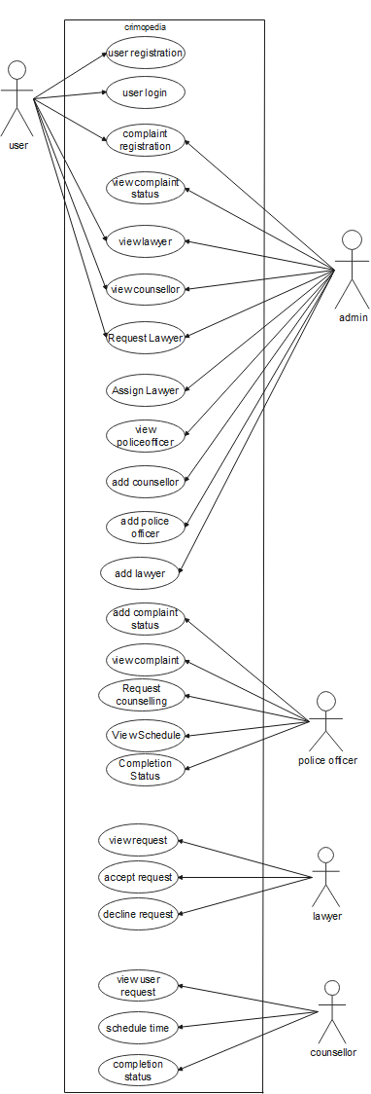

## SEQUENCE DIAGRAM

A sequence diagram fundamentally depicts the sequential order in which events occur or how they interact with one another. Event diagrams and event scenarios are other names for sequence diagrams. Sequence diagrams display the activities performed by a system's parts in time order. These diagrams are commonly used by businesspeople and software developers to explain and appreciate the requirements for new and existing systems.

### Uses of sequence diagrams –

* Used to simulate and visualize the reasoning behind complex functions, operations, or processes.
* Used to comprehend the precise operation of present or future systems.
* Visualize the flow of tasks and messages within a system's objects or components.

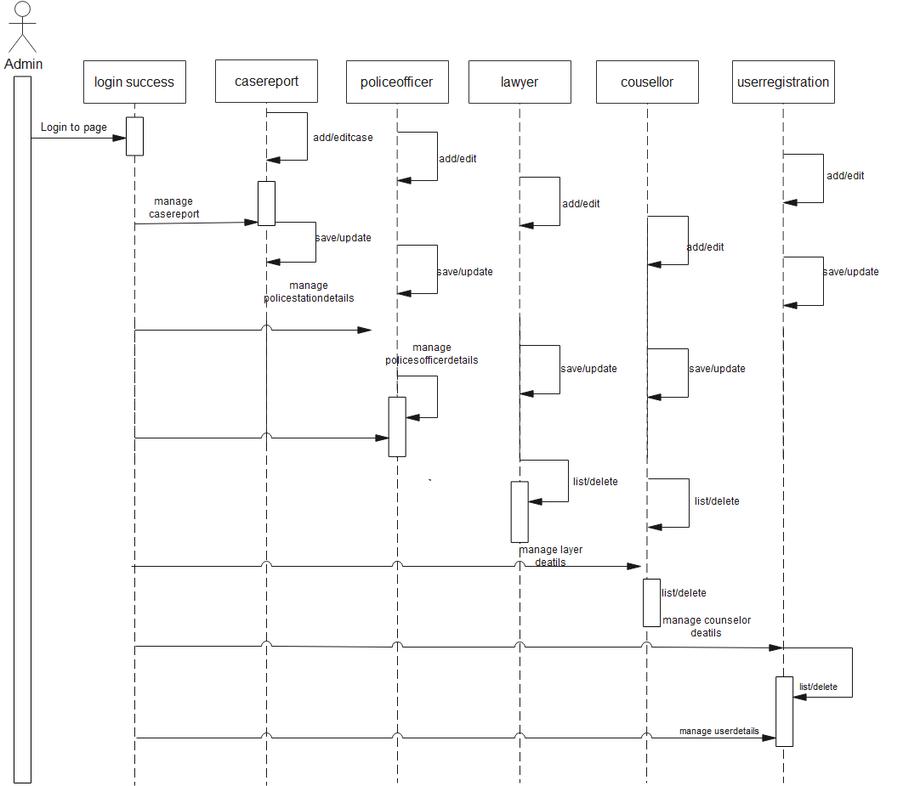

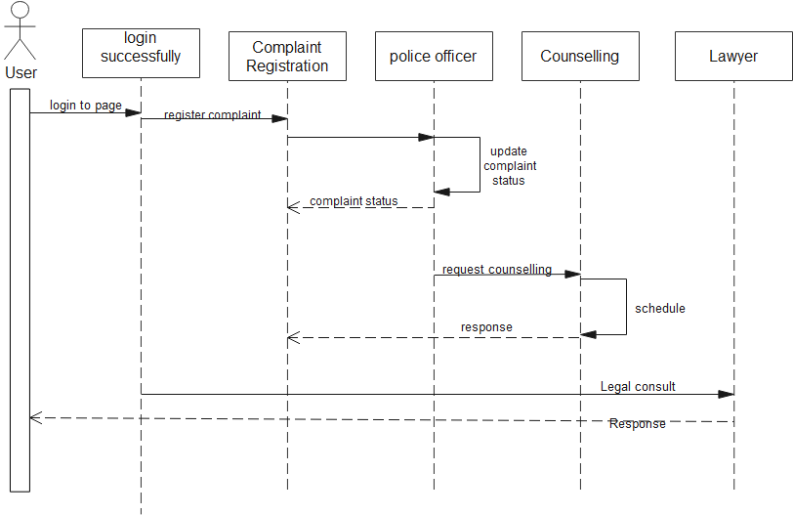

## State Chart Diagram

State diagrams are a common tool for displaying a software system's behavior. A state machine diagram in a UML model can describe the behavior of a class, a subsystem, a package, or even an entire system. It is also known as a state chart or a state transition diagram. We can effectively describe the communications or interactions that occur between external entities and a system using state chart diagrams. These diagrams are used to model the event-based system. An event can be used to control an object's state. State chart diagrams are used to show the various states of an entity within the application system.

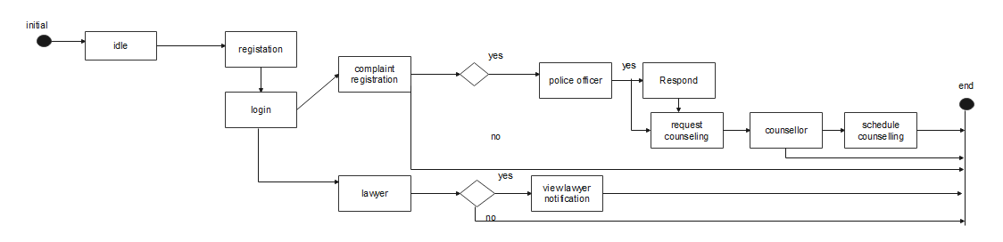

## Activity Diagram

Activity diagrams demonstrate the coordination of several layers of activity abstraction necessary to deliver a service. Usually, a few operations are required to complete an event, especially when those operations must coordinate numerous separate tasks. How the events in a single use case interact to one another is another frequent need, particularly in use cases where activities may overlap and require coordination. Additionally, it is suitable for simulating the coordination amongst a collection of use cases that serve as examples of business activities.

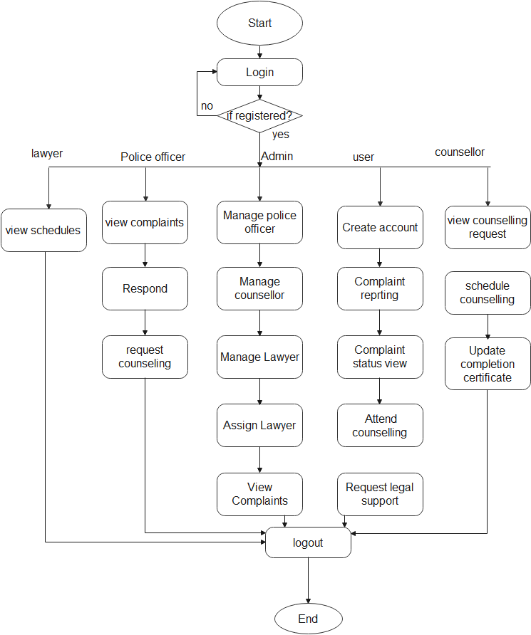

## Class Diagram

The most typical diagrams used in UML are class diagrams. The components of a class diagram include classes, interfaces, linkages, and collaboration. The object-oriented perspective of a system, which is static in nature, is essentially represented by class diagrams. An active class is used in a class diagram to illustrate the system's concurrency. A system's object orientation is represented by a class diagram. It is therefore typically utilised for development purposes. At the time the system was being built, this diagram was the one that was utilised the most.

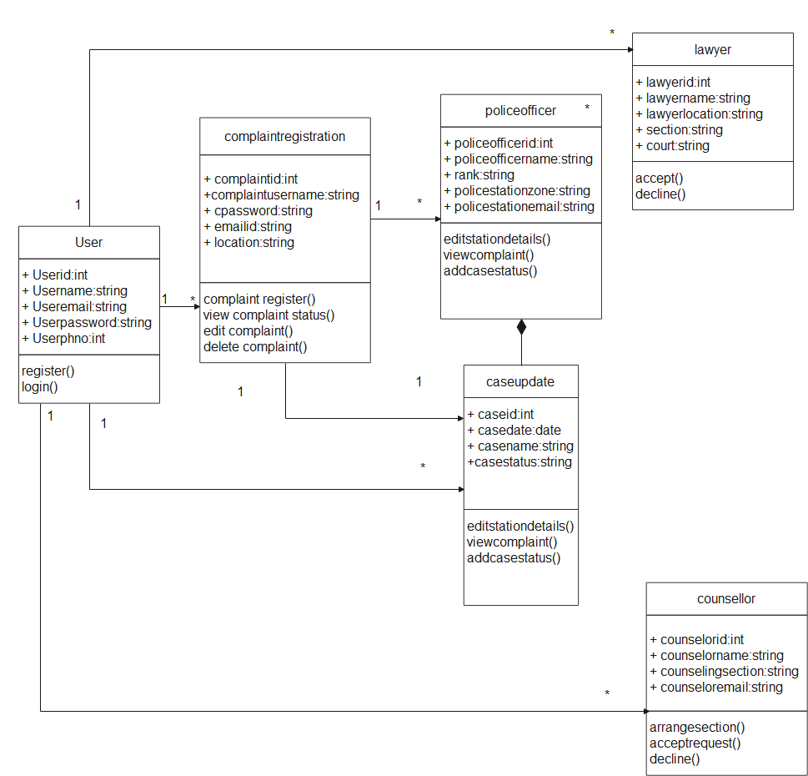

## Object Diagram

Class diagrams are a need for object diagrams since they are the source of class diagrams. An object diagram illustrates a specific instance of a class diagram. Diagrams of classes and objects have the same underlying concepts. Object diagrams are also used to illustrate a system's static view, which is a brief transient picture of the system. Object diagrams are used to illustrate a collection of things and their connections, for example.

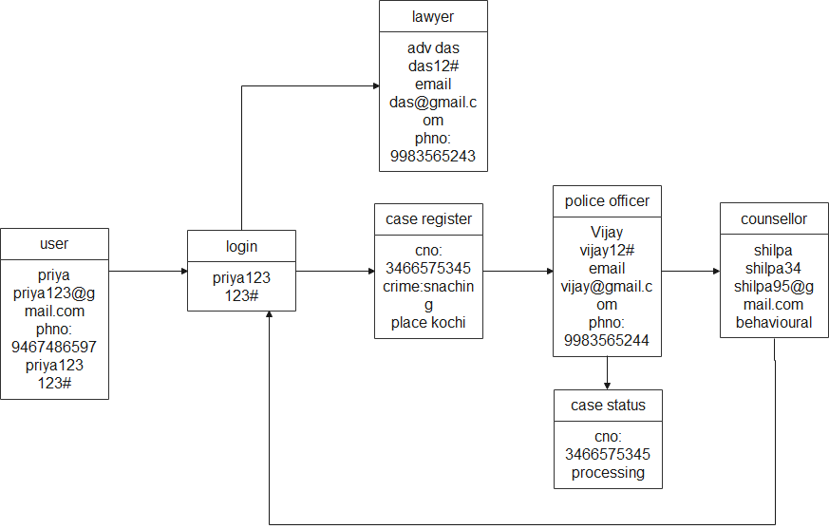

## Component Diagram

Component diagrams have different behaviors and personalities. The physical parts of the system are represented using component diagrams. Executables, libraries, files, documents, and other items that are physically present in a node are just a few examples. Component diagrams are used to show how a system's components are connected and arranged. These designs are also used to develop executable systems.

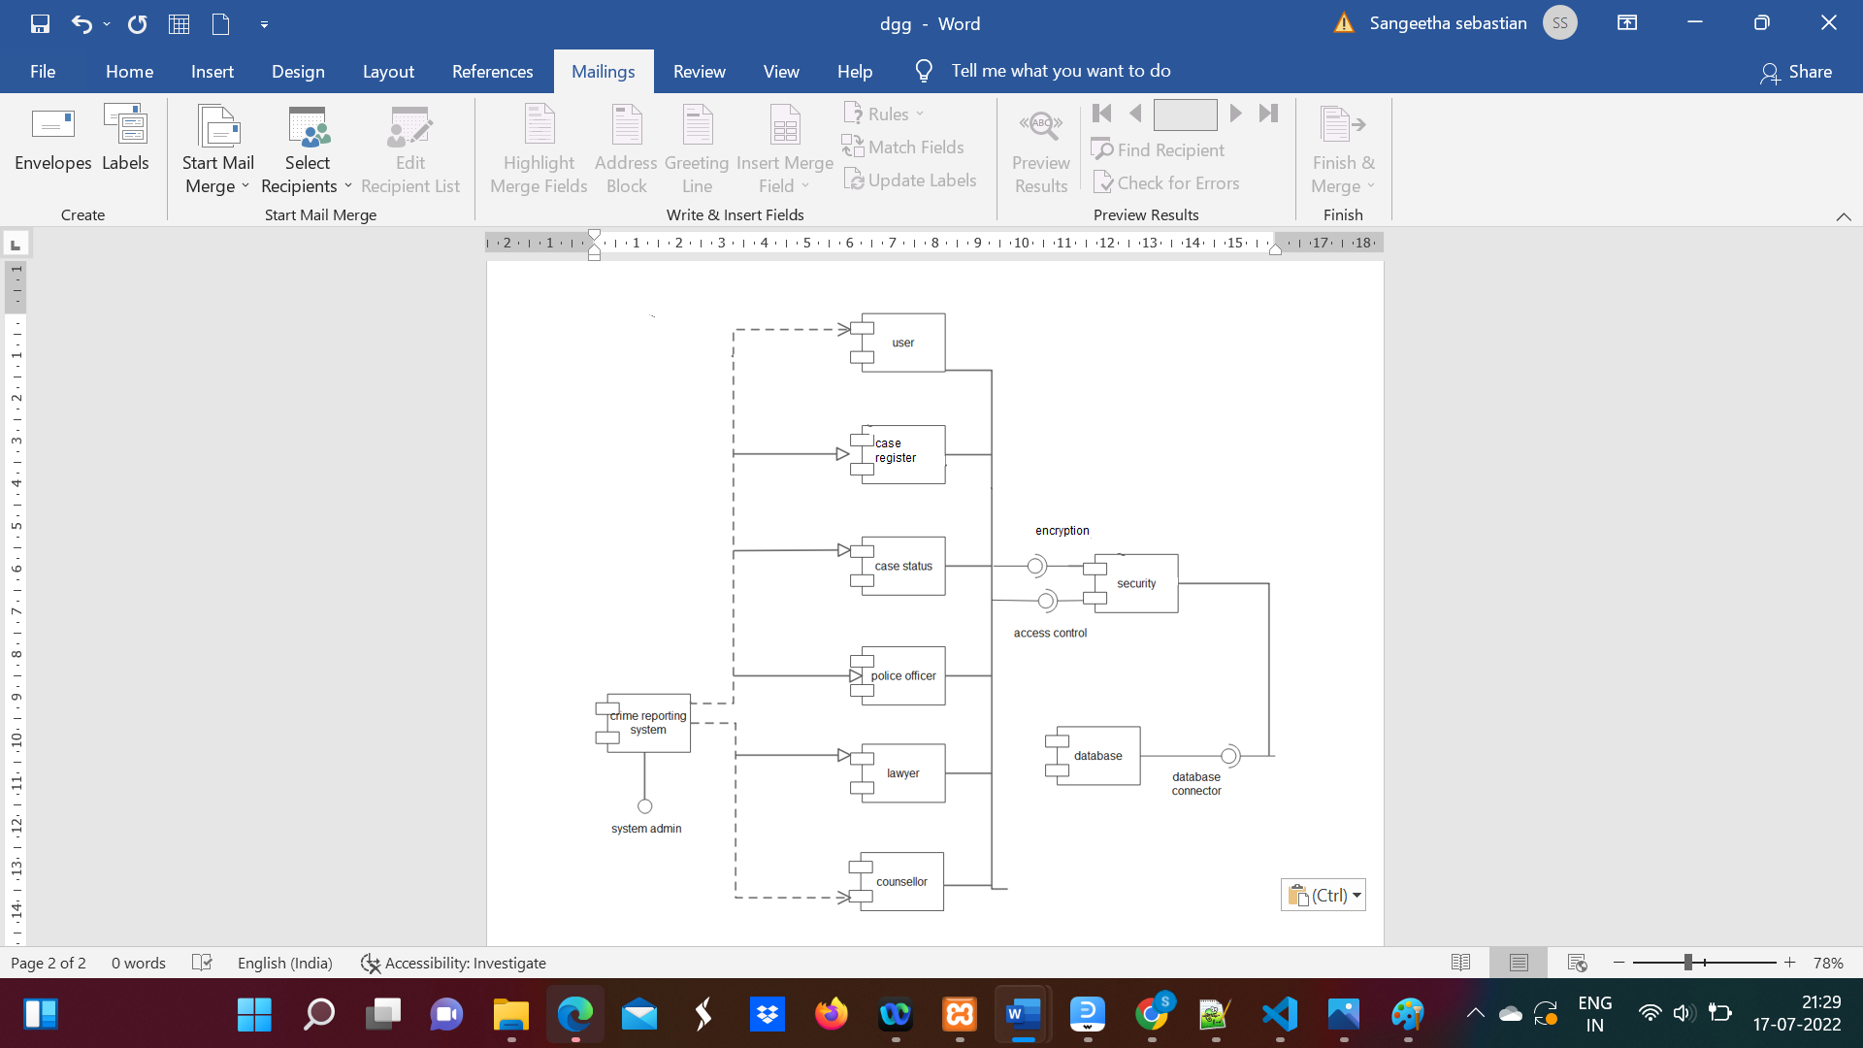

**4.2.8 Deployment Diagram**

Deployment diagrams show the layout of the system's actual hardware, where the software components are deployed. Using deployment diagrams, a system's static deployment perspective is explained. Nodes and their connections make up deployment diagrams.

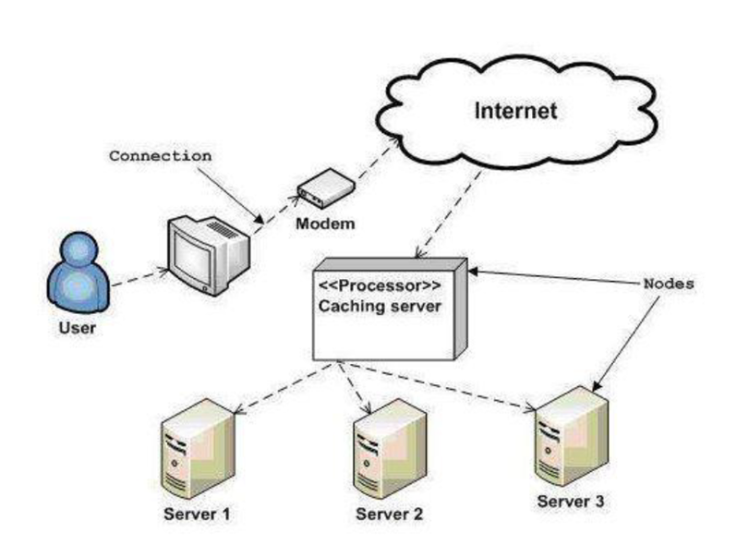

### 4.3 USER INTERFACE DESIGN USING FIGMA

**Form Name : User Registration**

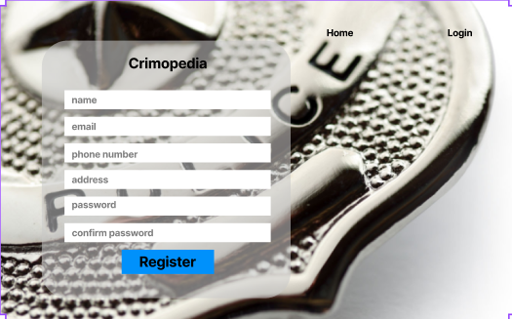

**Form Name : User Login**

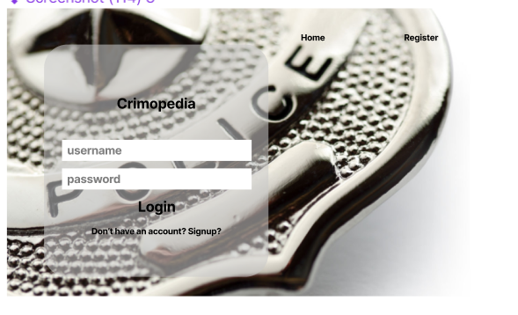

F**orm Name: Complaint Form**

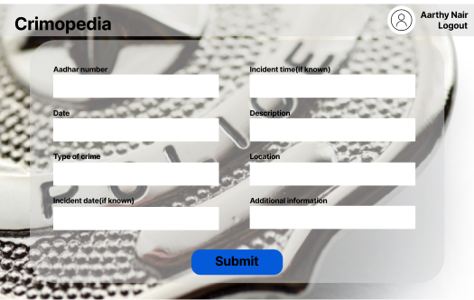

**Form Name: Admin Panel**

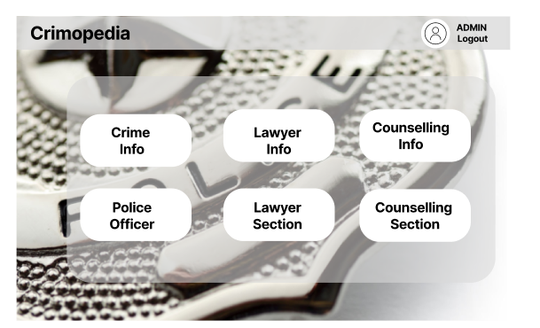

**Form Name: Add Lawyer Section**

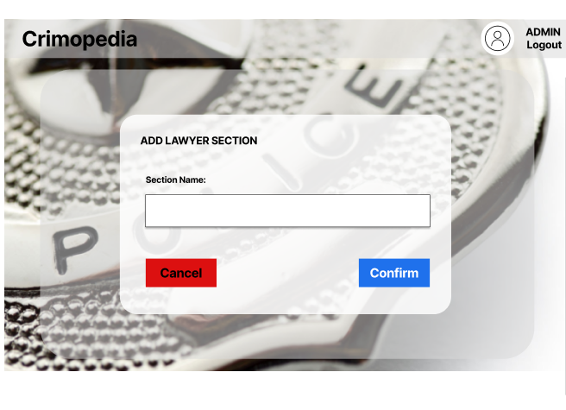

**Form Name: Assign Lawyer**

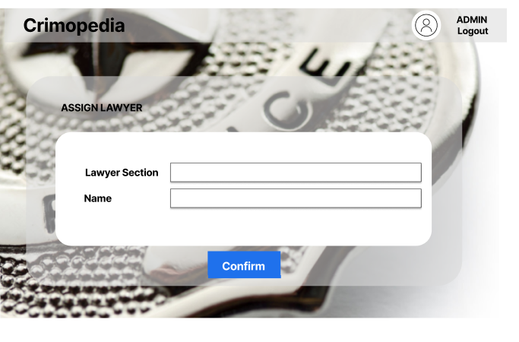

**Form Name: User Interface**

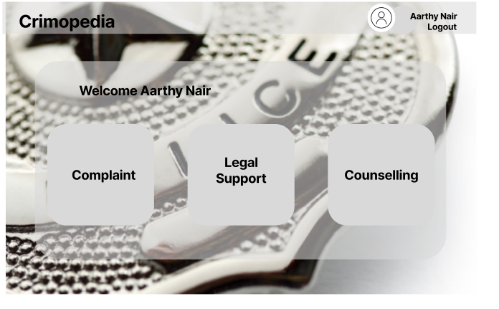

## DATABASE DESIGN

A database is a well-organized system that has the ability to store data and enables users to retrieve that data quickly and efficiently. The goal of every database is the data, which must be safeguarded.

The process of designing a database involves two steps. The initial phase involves gathering user demands, after which a database is built to as clearly as possible meet these requirements. Information Level Design is the name of this stage, which is carried out independently of any specific DBMS.

This information level design is converted into a design for the particular DBMS that will be used to construct the system in question in the second stage. Physical Level Design is the phase in which the qualities of the chosen DBMS are discussed. The system design and the database design are concurrent. The following two main goals are intended to be attained by the way the database's data is organized.

* + - Data Integrity
    - Data independence

### Relational Database Management System (RDBMS)

A relational model presents the database as a set of connections. Every relation looks as a table or file of records with values. A row is known as a tuple in the formal language of the relational model, a column heading is known as an attribute, and the table is known as a relation. The tables in a relational database are organized into groups and given individual names. A row in a story reflects a collection of associated values.

**Relationships**

* + - * Key is used to create table connections. Primary Key and Foreign Key are the two principal keys that are most crucial. Referential integrity as well as entity integrity, these are the basics of establishing relationships.
      * No Primary Key may contain null values, per Entity Integrity.
      * Referential Integrity for each distinct Foreign Key value, there must exist a matching Primary Key value in the same domain. Other key is Super Key and Candidate Keys.

### Normalization

The simplest possible grouping of data is used to put them together so that future modifications may be made with little influence on the data structures. The formal process of normalizing data structures in a way that reduces duplication and fosters integrity. Using the normalization approach, superfluous fields are removed and a huge table is divided into several smaller ones. Anomalies in insertion, deletion, and updating are also prevented by using it. Keys and relationships are two notions used in the normal type of data modelling. All the tables have been normalized up to the third normal form.

**First Normal Form**

The First Normal Form states that the domain of each attribute must only include atomic values and that the value of each attribute in a tuple must be a single value from that domain. Meaning that relationships cannot be used as attribute values within tuples or relations within relations, 1NF bans this. The only attribute values that are allowed under 1NF are single atomic or indivisible values. It is necessary to first enter the data into First Normal Form. This can be achieved by transferring data into other tables that also include data of a similar type.

### Second Normal Form

When the primary key includes many characteristics, Second Normal Form states that no non-key attribute should be functionally dependent on any part of the primary key. To achieve this, a new connection must be established for each partial key, which entails decomposing each partial key into its dependent attributes. The initial primary key and any attributes that are solely dependent on it should be kept in the database. A connection is said to be in second normal form only if and only if its primary key alone fits all the criteria for first normal form for the relation's main key and all of its non-primary key features.

### Third Normal Form

According to the Third Normal Form, a relation should not have a non-key attribute that is functionally determined by another non-key property or by a group of non-key characteristics. Non-key characteristics that serve as functional dependencies for other non-key characteristics are thus broken down and arranged in relation. This procedure is used to get rid of anything not wholly dependent on the primary key. A relationship is said to be in third normal form if it is in second normal form and, more significantly, if

none of its non-key characteristics depend on any other non-key characteristics.

**4.6.3 Sanitization**

Sanitization changes the input to make sure it is legitimate (such as doubling single quotes). Normally, you would combine these two strategies to give your application comprehensive defense. For instance, you may convert all single quotation marks in a string to double quotation marks (sanitize) before verifying that all the quotation marks had indeed been converted (validate). Testing the length, format, range, and permitted characters are all examples of validation tests. For instance, you must verify that any text input only contains the numbers 0 through 9 if your application only accepts positive integer input.

**4.6.4 Indexing**

By reducing the number of disc accesses needed when a query is completed, indexing helps a database perform better. It is a data structure method used to locate and access data in a database rapidly. Several database columns are used to generate indexes. The primary key or candidate key of the table is duplicated in the first column, which is the Search key. To make it easier to find the related data, these values are kept in sorted order. The Data Reference or Pointer column, which appears in the second row, comprises a set of pointers that each represent the location of the disc block where the specific key value is stored.

### TABLE DESIGN

**1.Tbl_users_login**

Primary key: **loginid**

|  |  |  |  |  |
| --- | --- | --- | --- | --- |
| No: | Field | Datatype | Key Constraints | Description |
| 1 | Loginid | Int (11) | Primary key | Loginid |
| 2 | Username | Varchar (20) | Not Null | Username of  login person |
| 4 | Password | Varchar (20) | Not Null | password |
| 5 | Role | Varchar (10) | Not Null | Type of the login |

**2.Tbl_user_registration**

Primary k : **us_id**

Foreign key **loginid** references table **Tbl_users_login**

|  |  |  |  |  |  |
| --- | --- | --- | --- | --- | --- |
| No: | Field | Datatype | Key Constraint | Description |  |
| 1 | us_id | Int (10) | Primary key | User id |
| 2 | name | Varchar (20) | Not null | username |
| 3 | gender | Char (4) | Not null | Gender of the  user |
| 4 | phno | Int (10) | Not null | Phone number of  the user |
| 5 | email | Varchar (30) | Not null | Mail id of the  user |
| 6 | Addrline1 | Varchar (50) | Not null | User house name |
| 7 | Addrline2 | Varchar (50) | Not null | Place |
| 8 | Addrline3 | Varchar (50) | Not null | City |
| 9 | Dist | Varchar (20) | Not null | District |
| 10 | state | Varchar (20) | Not null | State |
| 11 | Aadhar_number | Int (12) | Not null | Aadhar number |

**3.Tbl_complaint_registration**

Primary key **cid**

Foreign Key: **login_id references tbl_users_login**

|  |  |  |  |  |
| --- | --- | --- | --- | --- |
| No: | Field | Datatype | Key Constraint | Description |
| 1 | **cid** | Int (11) | Primary Key | Complaint Id |
| 2 | c_date | date | Not null | Complaint reporting date |
| 3 | c_description | Varchar (100) | Not null | Brief description about complaint |
| 4 | c_status | Varchar (11) | Not null | pending |
| 5 | type_crime | Int (50) | Not null | Describe the type of crime |
| 6 | location | Varchar (20) | Not null | Location of the incident happened |
| 7 | login_id | Int (11) | Foreign Key | Login id of the user |
| 8 | reason | Varchar (50) | Not null | Describe the reason |
| 9 | solution | Varchar (50) | Not null | Describe the solution |
| 10 | incident_date | date | Not null | Incident occurred date |
| 11 | incident_time | time | Not null | Incident occurred time |

**4.Tbl_police_officer**

Primary key: **officer_id**

|  |  |  |  |  |
| --- | --- | --- | --- | --- |
| No: | Field | Datatype | Key constraints | Description |
| 1 | Officer_id | Varchar (10) | Primary key | Police officer id |
| 2 | Officer_name | Varchar (20) | Not null | Officer name |
| 3 | Police station | Varchar (20) | Not null | Police station details of the officer |
| 4 | Officer_rank | Varchar (50) | Not null | Rank of the police officer |
| 5 | Officer_location | Varchar (20) | Not null | Location |
| 6 | zone | Varchar (20) | Not null | Station zone |
| 7 | range | Varchar (20) | Not null | range |

**5.Tbl_add_lawyer**

Primary key: **aid**

Foreign Key: **login_id reference tbl_users_login**

Foreign Key: **sec_id reference tbl_lawyer_section**

|  |  |  |  |  |
| --- | --- | --- | --- | --- |
| No: | Field | Datatype | Key constraints | Description |
| 1 | **aid** | Int (10) | Primary Key | Advocate id |
| 2 | a_name | Varchar (20) | Not null | Advocate name |
| 3 | mobile | Int (10) | Not null | Advocate mobile number |
| 4 | office_address | Varchar (200) | Not null | Advocate office address |
| 5 | city | Varchar (200) | Not null | City that advocates office  situated |
| 6 | state | Varchar (200) | Not null | State |
| 7 | district | Varchar (200) | Not null | District |
| 8 | experience | Int (20) | Not null | Working experience in year |
| 9 | sec_id | Int (11) | Foreign Key | Section that advocate specialize |
| 10 | court | Varchar (200) | Not null | Court where the advocate  working |
| 11 | login_id | Int (10) | Foreign Key | Login id of the advocate |
| 12 | qualification | Varchar (100) | Not null | Describe the qualification of  advocate |

**6.Tbl_counselling**

Primary key: **coid**

Foreign Key: **login_id reference tbl_users_login**

Foreign Key: **counselling_id reference tbl_counselling_section**

|  |  |  |  |  |
| --- | --- | --- | --- | --- |
| No: | Field | Datatype | Key constraints | Description |
| 1 | **coid** | Int (10) | Primary Key | Counsellor id |
| 2 | co_name | Varchar (20) | Not null | Counsellor name |
| 3 | co_mobile | Int (10) | Not null | Counsellor mobile number |
| 4 | co_office | Varchar (20) | Not null | Counsellor office address |
| 5 | co_city | Varchar (20) | Not null | Counsellor city |
| 6 | co_state | Varchar (20) | Not null | Counsellor state |
| 7 | co_district | Varchar (20) | Not null | Counsellor district |
| 8 | counselling_id | Int (11) | Foreign Key | Counselling section id |
| 9 | co_experience | Varchar (20) | Not null | Counsellor working experience  in year |
| 10 | login_id | Int (11) | Foreign Key | Login id of the counsellor |

**7.Tbl_counselling_request**

Primary key: **officer_id**

Foreign Key: **login_id reference tbl_users_login**

Foreign Key: **cid reference tbl_complaint_registration**

Foreign Key: **section reference tbl_counselling_section**

Foreign Key: **coid reference tbl_counselling**

|  |  |  |  |  |
| --- | --- | --- | --- | --- |
| No: | Field | Datatype | Key constraints | Description |
| 1 | **req_id** | Int (11) | Primary Key | Request id |
| 2 | login_id | Int (11) | Foreign Key | Login id of the police officer who request for the counselling |
| 3 | cid | Int (11) | Foreign Key | Complaint id from complaint registration table |
| 4 | section | Varchar (25) | Foreign Key | Counselling section |
| 5 | coid | Int (11) | Foreign Key | Counsellor id |

**8.Tbl_counselling_section**

Primary key: **counselling id**

|  |  |  |  |  |
| --- | --- | --- | --- | --- |
| No: | Field | Datatype | Key constraints | Description |
| 1 | **counselling_id** | Int (10) | Primary Key | Counselling id |
| 2 | counselling_section | Varchar (100) | Not Null | Describe the section |

**9.Tbl_crime_section**

Primary key: **crime_id**

|  |  |  |  |  |
| --- | --- | --- | --- | --- |
| No: | Field | Datatype | Key constraints | Description |
| 1 | **crime_id** | Int (11) | Primary Key | Crime id |
| 2 | crime | Varchar (20) | Not Null | Crime name |
| 3 | crime_section | Varchar (50) | Not Null | Corresponding IPC section for the crime |

**10. Tbl_lawyer_section**

Primary key: **officer_id**

|  |  |  |  |  |
| --- | --- | --- | --- | --- |
| No: | Field | Datatype | Key constraints | Description |
| 1 | **sec_id** | Int (11) | Primary Key | Section id |
| 2 | category | Varchar (50) | Not Null | Lawyer specialization section |

**11.Tbl_tbl_amount**

Primary key: **amount_id**

Foreign key: **coid reference tbl_counselling**

|  |  |  |  |  |
| --- | --- | --- | --- | --- |
| No: | Field | Datatype | Key constraints | Description |
| 1 | **amount_id** | Int (11) | Primary Key | Amount id |
| 2 | coid | Int (11) | Foreign Key | Counsellor id |
| 3 | amount | Int (11) | Not Null | Amount to pay |

**12.Tbl_payment_counselling**

Primary key : **pay_id**

Foreign key: **login_id reference tbl_users_login**

|  |  |  |  |  |
| --- | --- | --- | --- | --- |
| No: | Field | Datatype | Key constraints | Description |
| 1 | **pay_id** | Int (11) | Primary Key | Payment id |
| 2 | login_id | Int (11) | Foreign Key | Login id of the user |
| 3 | amount | Int (11) | Not Null | Amount paid |
| 4 | date | timestamp | Not Null | Date of the payment done |
| 5 | status | Varchar (11) | Not Null | paid |

**13.Tbl_assign**

Primary key: **assign_id**

Foreign Key: **request_id reference tbl_police_officer**

Foreign Key: **l_section**

|  |  |  |  |  |
| --- | --- | --- | --- | --- |
| No: | Field | Datatype | Key constraints | Description |
| 1 | **assign_id** | Int (11) | Primary Key | Assigning id |
| 2 | request_id | Int (11) | Foreign Key | Request id of the client |
| 3 | l_section | Int (11) | Foreign Key | Law section |
| 4 | lawyer_name | Varchar (20) | Not null | Lawyer name |

**14.Tbl_consult**

Primary key: **request_id**

Foreign Key: **login_id**

|  |  |  |  |  |
| --- | --- | --- | --- | --- |
| No: | Field | Datatype | Key constraints | Description |
| 1 | **request_id** | Int (11) | Primary Key | Request id |
| 2 | login_id | Int (11) | Foreign Key | Login id of the user |
| 3 | date | date | Not null | Consulting date |
| 4 | time | time | Not Null | Consulting time |
| 5 | mode | Varchar (10) | Not Null | Consulting mode |
| 6 | comment | Varchar (500) | Not Null | Describe the legal matter |
| 7 | section | Varchar (50) | Not Null | Which section of advocate is want |

**15.Tbl_policerespond**

Primary key: **officer_id**

Foreign Key: **cid**

|  |  |  |  |  |
| --- | --- | --- | --- | --- |
| No: | Field | Datatype | Key constraints | Description |
| 1 | **res_id** | Int (11) | Primary Key | Response id |
| 2 | cid | Int (11) | Foreign Key | Complaint id |
| 3 | response | Varchar (200) | Not Null | Response for the complaint |

**16.Tbl_sechedule**

Primary key: **officer_id**

|  |  |  |  |  |
| --- | --- | --- | --- | --- |
| No: | Field | Datatype | Key constraints | Description |
| 1 | **sid** | Int (11) | Primary Key | Schedule id |
| 2 | s_date | date | Not Null | Counselling scheduled date |
| 3 | s_time | time | Not Null | Counselling scheduled time |
| 4 | req_id | Int (11) | Foreign Key | Request_id |
| 5 | coid | Int (11) | Foreign Key | Counsellor id |

**CHAPTER 5**

**SYSTEM TESTING**

* 1. **INTRODUCTION**

Software testing is the practice of carefully controlling the execution of software in order to determine if it behaves as intended. The terms "software testing" and "verification and validation" are frequently used together. Validation is the process of examining or evaluating a product, including software, to determine if it complies with all relevant specifications. One type of verification, software testing, employs methods including reviews, analyses, inspections, and walkthroughs as well. Verifying that what has been specified matches what the user truly want is the process of validation.

Testing is a collection of activities that may be planned ahead of time and carried out in a methodical manner. Testing starts with individual modules and progresses all the way to system integration for computer-based systems. Nothing is complete without testing, as it is essential to the system's testing goals. Several guidelines can be used as testing goals. They are:

Testing is a process of executing a program with the intent of finding an error.

* A excellent test case has a high likelihood of detecting an unknown error.
* A successful test is one that uncovers an undiscovered error.

If a test is successfully carried out in accordance with the aforementioned aims, it will reveal software bugs. Additionally, testing shows that the software function seems to operate in accordance with the specification and that the performance criterion was reached.

There are three reasons to test program.

* For correctness
* For implementation efficiency
* For computational complexity

## TEST PLAN

The procedures that must be followed in order to fulfil various testing techniques are suggested in a test plan. The test plan specifies the activities that must be completed. Software developers are responsible for creating a computer programme, as well as any related documentation and data structures. It is always the software developers' job to test each of the program's individual components to ensure that it serves the intended function. The precise objectives of testing should be stated in terms of numbers. The test strategy should thus contain details about the mean time to failure, the expense of finding and fixing faults, the density or frequency of recurrence of residual defects, and the number of test labour hours needed for each regression test.

The levels of testing include:

* Unit testing
* Integration Testing
* Data validation Testing
* Output Testing

### Unit Testing

Unit testing concentrates verification efforts on the software component or module, which is the smallest unit of software design. The component level design description is used as a reference for testing crucial control pathways to find faults inside the module's perimeter. the level of test complexity and the untested area determined for unit testing. Unit testing is white-box focused, and numerous components may be tested simultaneously. To guarantee that data enters and exits the software unit under test appropriately, the modular interface is checked. To make sure that data temporarily stored retains its integrity during each step of an algorithm's execution, the local data structure is inspected. To confirm that each statement in a module has been performed at least once, boundary conditions are evaluated. All error handling pathways are then evaluated.

### Integration Testing

Integration testing is a methodical approach for creating the program's structure while also carrying out tests to find interface issues. The goal is to construct a programme structure that has been determined by design using unit tested components. The software as a whole is tested. Correction is challenging since the size of the overall programme makes it hard to isolate the reasons. As soon as these mistakes are fixed, new ones arise, and the process repeats itself in an apparently unending cycle. All of the modules were merged once unit testing was completed in the system to check for any interface inconsistencies. Additionally, variations in programme architectures were eliminated, and a singular programme structure developed.

### Validation Testing or System Testing

The testing process ends with this phase. In this, the complete system, including all forms, code, modules, and class modules, was tested as a whole. Popular names for this type of testing include system tests and black box testing.

The functional requirements of the programme are the main emphasis of the black box testing approach. That example, using Black Box testing, a software engineer may create sets of input circumstances that will fully simulate all of a program's functional requirements.

Problems in data structures or external data access, erroneous or missing functions, interface faults, performance issues, initialization issues, and termination issues are all types of errors that black box testing looks for.

### Output Testing or User Acceptance Testing

User approval of the system under consideration is tested; in this case, it must meet the needs of the company. When developing, the programme should stay in touch with the user and perspective system to make modifications as needed. This done with respect to the following points:

* + - * Input Screen Designs,
      * Output Screen Designs,

A variety of test data are used to conduct the aforementioned tests. The process of system testing requires the preparation of test data. The system under examination is then tested using the sample data that has been prepared. When testing the system, test data issues are found again and fixed using the testing procedures described above. The fixes are also logged for use in the future.

**5.2.5** **Automation Testing**

Automatic tests are performed on software and other computer products to ensure they adhere to strict standards. Basically, it's a test to make that the hardware or software works precisely as it should. It looks for mistakes, faults, and any other issues that could arise over the course of the product's construction. Automation testing may be done at any time of day. By use of predefined sequences, the software is examined. The findings are then summarised, and this information may be compared to the outcomes of prior test runs.

**5.2.6 Selenium Testing**

Selenium is an open-source application that automates web browsers. You may write test scripts using a single interface in a variety of computer languages, including Ruby, Java, NodeJS, PHP, Perl, Python, and C#. The Selenium testing tool automates the cross-browser compatibility testing of web applications. It is used to ensure high-quality web apps, whether they are responsive, progressive, or conventional. Selenium is a free piece of software.

**Test Case 1**

**code**

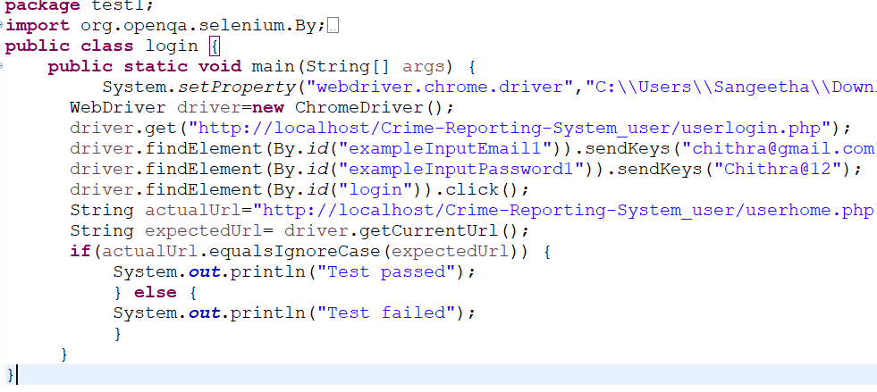

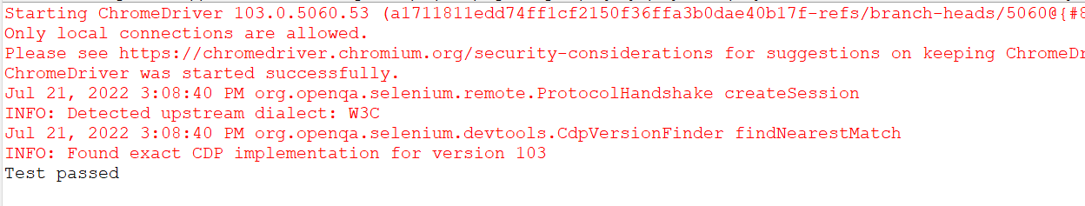

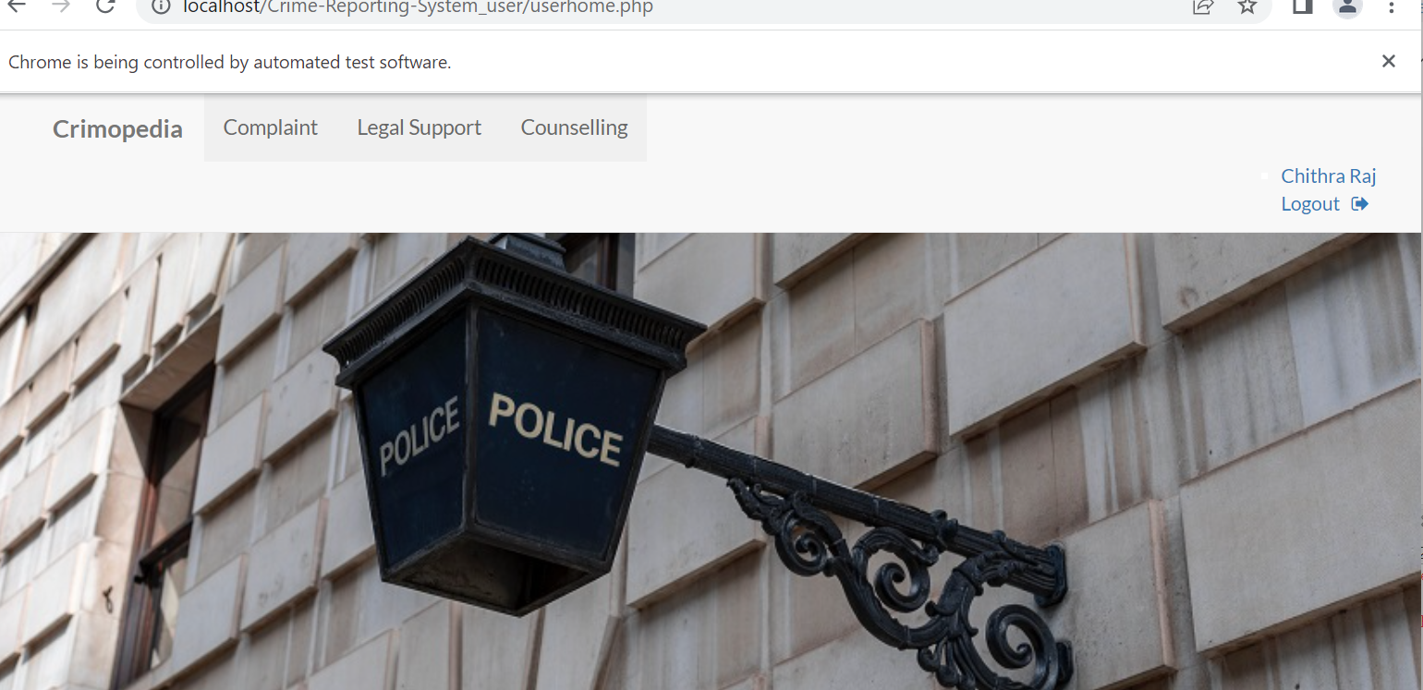

|  |  |  |  |  |  |
| --- | --- | --- | --- | --- | --- |
| **Test Case 1** | | | | | |
| **Project Name: Crimopedia** | | | | | |
| **Login Test Case** | | | | | |
| **Test Case ID: Test_1** | | | **Test Designed By: Sangeetha V Sebastian** | | |
| **Test Priority(Low/Medium/High):**High | | | **Test Designed Date:** 18-07-2022 | | |
| **Module Name**: Login Screen | | | **Test Executed By : Meera Rose Mathew** | | |
| **Test Title :** Verify login with username and password | | | **Test Execution Date:** 18-07-2022 | | |
| **Description:** Test the Login Page | | |  | | |
| **Pre-Condition :**User has valid username and password | | | | | |
| **Step** | **Test Step** | **Test Data** | **Expected Result** | **Actual Result** | **Status(Pass/**  **Fai l)** |
| 1 | Navigation toLogin Page |  | Login Page should be  displayed | Login page displayed | Pass |
| 2 | Provide Valid username | User Name: Chithra@gmail.com | User should be able to Login | User Logged in and navigated to Dashboard with records | Pass |
| 3 | Provide Valid Password | Password: Chithra@12 |
| 4 | Click on Sign In button |  |
| 5 | Provide Invalid | Username: Sreya |  |  |  |
|  | useranme or password | Password: Sreya@12 | User should not be able to Login | Alert for invalid Username or password displayed | Pass |
| 6 | Provide Null Email Id or Password | Email Id: null Password: null |
| 7 | Click on Sign In |  |  |  |  |
|  | button |  |  |  |
| **Post-Condition:** User is validated with database and successfully login into account.The Account session details are logged in database | | | | | |

**Test Case 2:**

**code**

**package** test1;

**import** org.openqa.selenium.By;

**import** org.openqa.selenium.WebDriver;

**import** org.openqa.selenium.chrome.ChromeDriver;

**public** **class** login {

**public** **static** **void** main(String[] args) {

System.*setProperty*("webdriver.chrome.driver","C:\\Users\\Sangeetha\\Downloads\\chromedriver_win32\\chromedriver.exe" );

WebDriver driver=**new** ChromeDriver();

driver.get("http://localhost/Crime-Reporting-System_user/userlogin.php");

driver.findElement(By.*id*("exampleInputEmail1")).sendKeys("chithra@gmail.com");

driver.findElement(By.*id*("exampleInputPassword1")).sendKeys("Chithra@12");

driver.findElement(By.*id*("login")).click();

driver.get("http://localhost/Crime-Reporting-System_user/lawyerconsultation.php");

driver.findElement(By.*id*("consult")).sendKeys("Domestic violence");

driver.findElement(By.*id*("date")).sendKeys("19-07-2022");

driver.findElement(By.*id*("time")).sendKeys("11:30");

driver.findElement(By.*id*("offline")).sendKeys("offline");

driver.findElement(By.*id*("legal")).sendKeys("legal matter");

driver.findElement(By.*id*("submit")).click();

String actualUrl="http://localhost/Crime-Reporting-System_user/paymentgateway.php";

String expectedUrl=

driver.getCurrentUrl();//driver.findElement(By.id("qty")).sendKeys("3");

//driver.findElement(By.id("cart1")).click();

**if**(actualUrl.equalsIgnoreCase(expectedUrl)) {

System.***out***.println("Test passed");

} **else** {

System.***out***.println("Test failed");

}

}

}

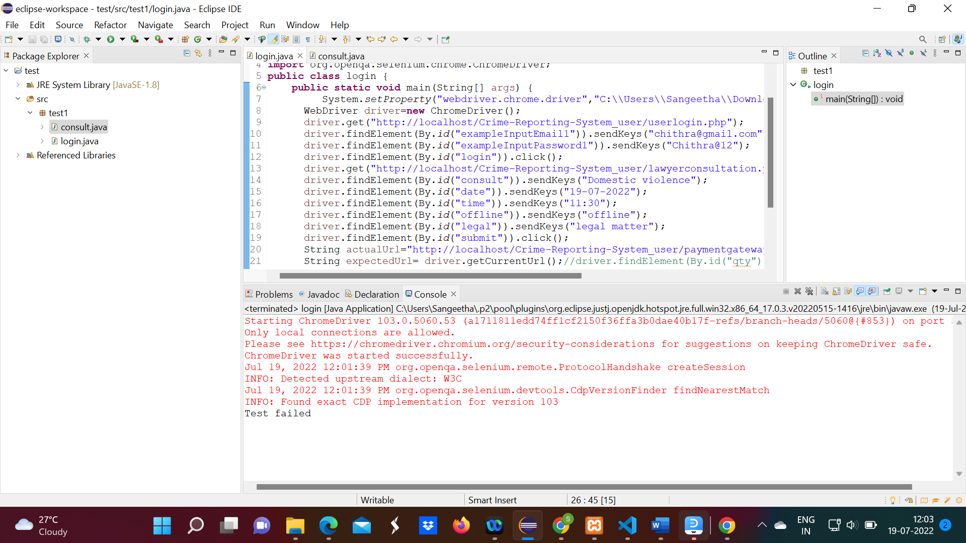

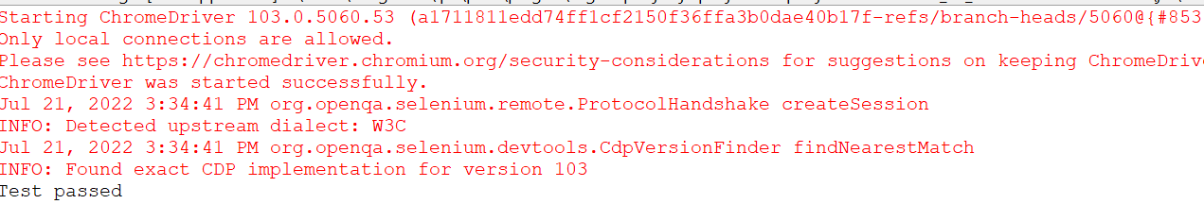

|  |  |  |  |  |  |
| --- | --- | --- | --- | --- | --- |
| **Test Case 2** | | | | | |
| **Project Name: Crimopedia** | | | | | |
| **Consult Test Case** | | | | | |
| **Test Case ID: Test_2** | | | **Test Designed By: Sangeetha V Sebastian** | | |
| **Test Priority (Low/Medium/High):** High | | | **Test Designed Date:** 18-07-2022 | | |
| **Module Name**: Login Screen | | | **Test Executed By: Meera Rose Mathew** | | |
| **Test Title:** Verify login with username and password | | | **Test Execution Date:** 18-07-2022 | | |
| **Description:** Test the Login Page | | |  | | |
| **Pre-Condition:** User has valid username and password | | | | | |
| **Step** | **Test Step** | **Test Data** | **Expected Result** | **Actual Result** | **Status (Pass/**  **Fai l)** |
| 1 | Navigation to Login Page |  | Login Page should be  displayed | Login page displayed | Pass |
| 2 | Provide Valid consultation section | Domestic violence |  | User Logged in and navigated to consultation form | Pass |
| **3** | Provide Valid date | 19-07-2022 |
| **4** | Provide Valid time | 10:30 |
| **5** | Consultation mode | offline |
| 6 | Provide Valid legal matter | Legal matter |
| 4 | Click on Sign In button |  |
| **Post-Condition:** User is validated with database and successfully login into account.The Account session details are logged in database | | | | | |

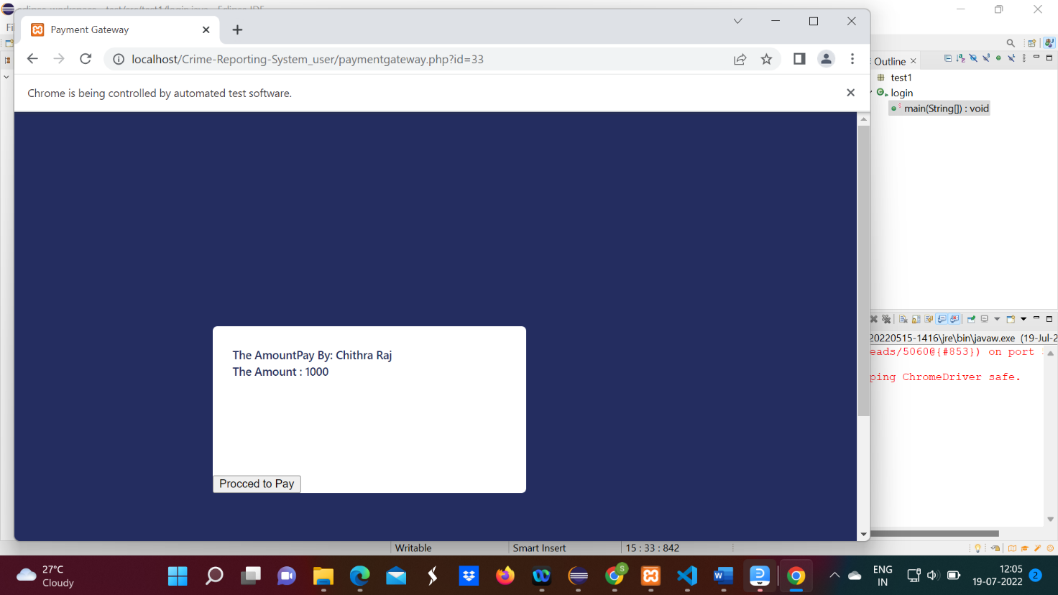

**Test Case:3**

**code**

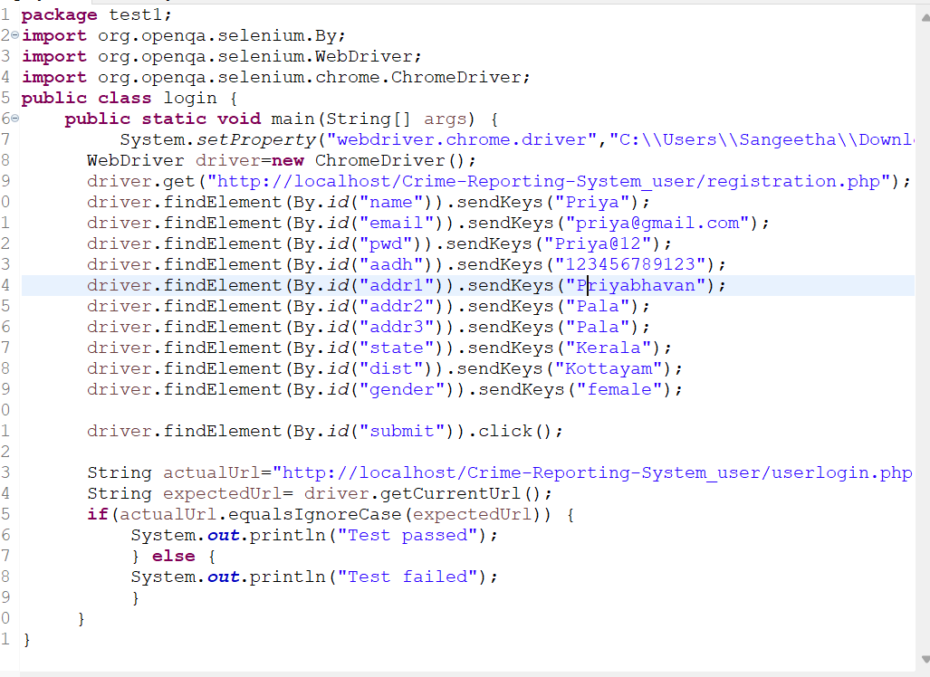

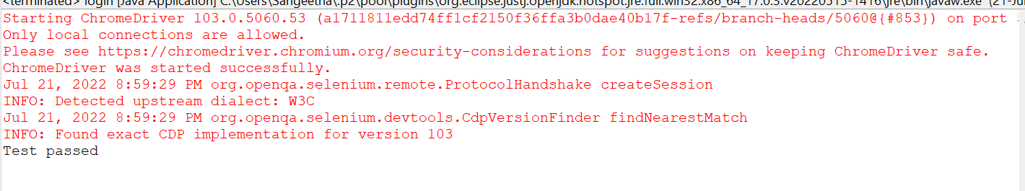

|  |  |  |  |  |  |
| --- | --- | --- | --- | --- | --- |
| **Test Case 3** | | | | | |
| **Project Name: Crimopedia** | | | | | |
| **Registration Test Case** | | | | | |
| **Test Case ID: Test_3** | | | **Test Designed By: Sangeetha V Sebastian** | | |
| **Test Priority (Low/Medium/High):** High | | | **Test Designed Date:** 18-07-2022 | | |
| **Module Name**: Login Screen | | | **Test Executed By: Meera Rose Mathew** | | |
| **Test Title:** Verify login with username and password | | | **Test Execution Date:** 18-07-2022 | | |
| **Description:** Test the Login Page | | |  | | |
| **Pre-Condition:** User has valid username and password | | | | | |
| **Step** | **Test Step** | **Test Data** | **Expected Result** | **Actual Result** | **Status (Pass/**  **Fai l)** |
| 1 | Navigation to Registration Page |  | Registration Page should be  displayed | Registration page displayed | Pass |
| 2 | Provide Name | Priya |  | User registered and navigated to login page | Pass |
| **3** | Provide  Email id | priya@gmail.com |
| **4** | Provide Password | Priya@12 |
| **5** | Provide Adhaar number | 123456789123 |
| **6** | Provide Address 1 | Priyabhavan |
| 7 | Provide  Address2 | Pala |
| 8 | Provide Address3 | Pala |
| 9 | Provide State | Kerala |
| 10 | Provide District | Kottayam |
| 11 | Provide gender | Female |
| 12 | Click on Sign Up button |  |
| **Post-Condition:** User is validated with database and successfully login into account. The Account session details are logged in database | | | | | |

**Test Case:4**

**Code**

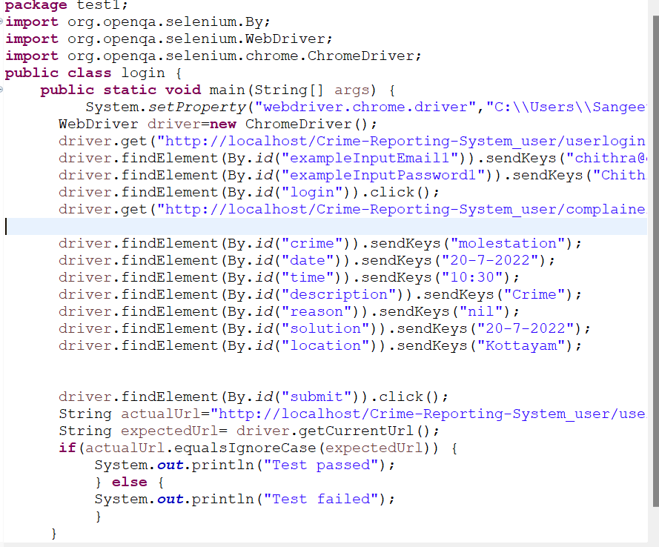

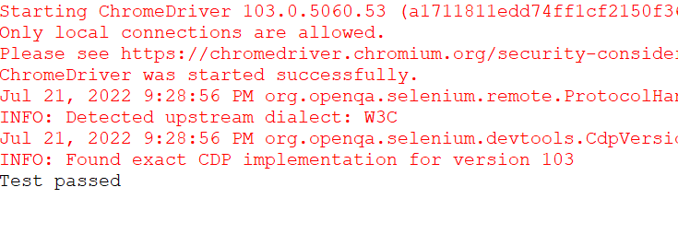

|  |  |  |  |  |  |
| --- | --- | --- | --- | --- | --- |
| **Test Case 3** | | | | | |
| **Project Name: Crimopedia** | | | | | |
| **Complaint formTest Case** | | | | | |
| **Test Case ID: Test_4** | | | **Test Designed By: Sangeetha V Sebastian** | | |
| **Test Priority (Low/Medium/High):** High | | | **Test Designed Date:** 19-07-2022 | | |
| **Module Name**: Login Screen | | | **Test Executed By: Meera Rose Mathew** | | |
| **Test Title:** Verify login with username and password | | | **Test Execution Date:** 19-07-2022 | | |
| **Description:** Test the Login Page | | |  | | |
| **Pre-Condition:** User has valid username and password | | | | | |
| **Step** | **Test Step** | **Test Data** | **Expected Result** | **Actual Result** | **Status (Pass/**  **Fai l)** |
| 1 | Navigation to Registration Page |  | Complaint page should be  displayed | Complaint page displayed | Pass |
| 2 | Provide Crime | molestation |  | User login in and navigated to complaint page | Pass |
| **3** | Provide  date | 20-7-2022 |
| **4** | Provide time | 10:30 |
| **5** | Provide description | crime |
| **6** | Provide reason | nil |
| 7 | Provide  solution | nil |
| 8 | Provide location | Kottayam |
| 12 | Click on submit  button |  |
| **Post-Condition:** User is validated with database and successfully login into account. The Account session details are logged in database | | | | | |

# CHAPTER 6

# IMPLEMENTATION

## INTRODUCTION

The conceptual design is developed into a usable system during the project's execution phase. Since it assures users that the system will function as planned and be dependable and accurate, it may be viewed as the most crucial stage in developing a successful new system. It focuses mostly on user education and documentation. Conversion often occurs either during or following user training. Implementation, which essentially means putting a new system design into action, is the process of making a recently revised system design operational..

The user department currently handles the heaviest burden, endures the most disturbance, and has the most impact on the system as it stands. If the implementation is not well planned or managed, it could cause confusion and turbulence.

The entire process of moving from the old system to the new one is referred to as implementation. The new system might replace a current human or automated system, be completely different, or be improved upon. A reliable system that meets organisational needs must be appropriately implemented. System implementation describes the process of putting the created system into use. This includes each step taken to transition from the old to the new systemThe system may only be placed into operation after comprehensive testing and if it is established that it is working in compliance with the requirements. Employees of the system evaluate the system's feasibility. As a system is put into place, the complexity of the system analysis and design work required to accomplish the three essential elements of education and training, system testing, and changeover will rise.

## IMPLEMENTATION PROCEDURES

The full installation of the package in the intended setting, as well as the system's usability and accomplishment of the planned applications, are all referred to as software implementation. Often, someone who will not be utilising the program commissions the software development project. In the initial stage people doubt about the software but we have to ensure that the resistance does not build up, as one has to make sure that:

* The new system's advantages must be known to the active user. Their faith in the software is increased.
* The user receives the appropriate instruction so that he feels confident using the program. Before examining the system, the user must be aware that the server software

to be running on the server in order to access the results. The real procedure won't happen if the server object is not active and functioning on the server.

### User Training

To prepare the user to test and alter the system is the goal of user training. The participants must have confidence in their capacity to advance the objective and reap the benefits of the computer-based system. As systems get more complex, training becomes increasingly important. User training teaches the user how to enter data, manage error messages, query the database, call up routines to create reports, and carry out other crucial operations.

### System Maintenance

Maintenance is the secret of system development. In the maintenance phase of its lifespan, a software product is actively functioning. After being deployed successfully, a system has to be maintained appropriately. System maintenance is a crucial step in the life cycle of software development. A system must be maintained in order to remain adaptable to changes in the system environment. Software maintenance obviously entails much more than just "Finding Mistakes".

### Training on the Application Software

After providing the necessary basic training on computer awareness the user will have to be trained on the new application software. This will give the underlying philosophy of the use of the new system such as the screen flow, screen design type of help on the screen, type of errors while entering the data, the corresponding validation check at each entry and the ways to correct the date entered. It should then cover information needed by the specific user/ group to use the system or part of the system while imparting the training of the program on the application. This training may be different across different user groups and across different levels of hierarchy

**6.2.4 Hosting**

Free web hosting frequently has such little features and capabilities that customers must pay to get what they require. The free website hosting service 000webhost, however, offers a number of useful features, such as a website builder, WordPress support, and no adverts. Users who want more services and support can upgrade to a paid plan, but according to our reviews, 000webhost is the finest free web hosting option for people who are really on a limited budget. Our readers have given 000webhost an average rating of 3.5 stars out of 5, and they frequently highlight this host's quality, features, and value in their evaluations. Continue reading to learn

more about what 000webhost has to offer and how to sign up.

## How to Set up Free Hosting with 000webhost?

* Head to [000webhost.com](https://www.000webhost.com/), and click that **free sign up** button.
* Now go to your email account and confirm the link that we’ve sent. Once verified, you can start creating a website.
* When you click the create button, there’s a prompt asking why you sign up with us. Choose your reason
* After that, you’ll get a form to fill the website’s name and password. This step will add the website to your 000webhost sites list.
* There are three options available to build your website: using site builder, WordPress, or uploading a website that you’ve developed.
* Click **install now**, and you’ll get another form to create the webmaster login. When you finished, click the **install** button.

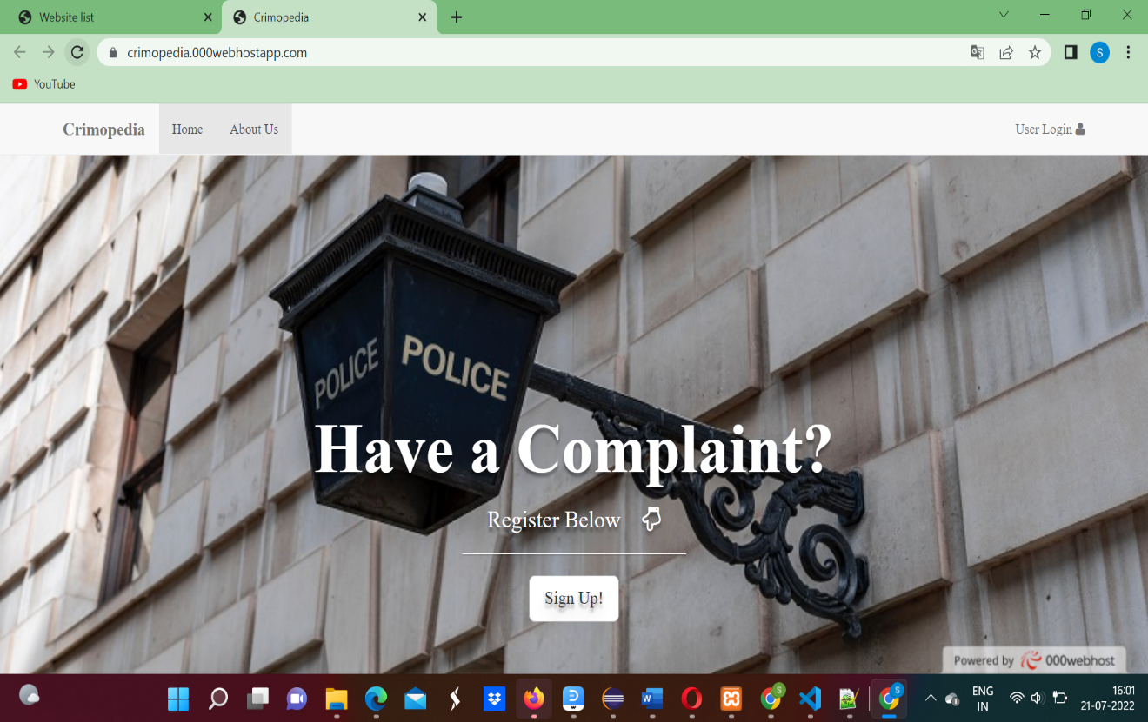

Link: https://crimopedia.000webhostapp.com/

# CHAPTER 7 CONCLUSION AND FUTURE SCOPE

## CONCLUSION

## 

The Online Crime Reporting System is a web application system which is too much helpful for all the common people, government organization and different societies. People must contact the nearest police station to register any complaints about crimes. Our approach streamlines the reporting and monitoring of crimes. On the basis of each particular case, counselling may be necessary for some people. Police personnel thus ask for counselling on behalf of persons who require it. The counselling request can be seen by counsellors in that section, who can then take further action. You can utilize this system to request legal counsel if you need it. Each request is considered, and assistance is given.

* 1. **FUTURE SCOPE**

The world is growing and crimes are also increasing. Reducing the growth of crimes is a very difficult task. The only way to prevent them is to report the crime immediately after it occurs. Crime reporting system will help a lot. Crime reporting can categorize. Categorizing crime reporting makes it easier for police officers to take immediate action.

# CHAPTER 8 BIBLIOGRAPHY

### REFERENCES:

* + - Gary B. Shelly, Harry J. Rosenblatt, “*System Analysis and Design*”, 2009.
    - Roger S Pressman, “*Software Engineering*”, 1994.
    - PankajJalote, “So*ftware engineering*: a precise approach”, 2006.
    - James lee and Brent ware Addison, “Open source web development with LAMP”, 2003
    - IEEE Std 1016 Recommended Practice for Software Design Descriptions.

### WEBSITES:

* + - [www.w3schools.com](http://www.w3schools.com/)
    - [www.jquery.com](http://www.jquery.com/)
    - [http://homepages.dcc.ufmg.br/~rodolfo/es-1-03/IEEE-Std-830-1998.pdf](http://homepages.dcc.ufmg.br/%7Erodolfo/es-1-03/IEEE-Std-830-1998.pdf)
    - [www.agilemodeling.com/artifacts/useCaseDiagram.html](http://www.agilemodeling.com/artifacts/useCaseDiagram.html)

# CHAPTER 9 APPENDIX

## Sample Code

### Login.html

### <?php

### include 'connect.php';

### ?>

### <!DOCTYPE html>

### <html>

### <head>

### <link rel="stylesheet" type="text/css" href="https://maxcdn.bootstrapcdn.com/bootstrap/3.3.5/css/bootstrap.min.css">

### <link rel="stylesheet" type="text/css" href="https://maxcdn.bootstrapcdn.com/font-awesome/4.4.0/css/font-awesome.min.css">

### <link href="http://fonts.googleapis.com/css?family=Lato:300,400,700,300italic,400italic,700italic" rel="stylesheet" type="text/css">

### 

### <script>

### function f1()

### {

### var sta2=document.getElementById("exampleInputEmail1").value;

### var sta3=document.getElementById("exampleInputPassword1").value;

### var x2=sta2.indexOf(' ');

### var x3=sta3.indexOf(' ');

### if(sta2!="" && x2>=0){

### document.getElementById("exampleInputEmail1").value="";

### document.getElementById("exampleInputEmail1").focus();

### alert("Space Not Allowed");

### }

### else if(sta3!="" && x3>=0){

### document.getElementById("exampleInputPassword1").value="";

### document.getElementById("exampleInputPassword1").focus();

### alert("Space Not Allowed");

### }

### }

### </script>

### 

### <title>Complainant Login</title>

### </head>

### <body style="background-size: cover;

### background-image: url(regi_bg.jpeg);

### background-position: center;">

### <nav class="navbar navbar-default navbar-fixed-top" style="height: 60px;">

### <div class="container">

### <div class="navbar-header">

### 

### <a class="navbar-brand" href="home.php" style="margin-top: 5%;"><b>Crimopedia</b></a>

### </div>

### <div id="navbar" class="collapse navbar-collapse">

### <ul class="nav navbar-nav">

### <li class="active" style="margin-top: 5%;"><a href="userlogin.php">User Login</a></li>

### </ul>

### 

### 

### </div>

### </div>

### </nav>

### <div align="center" >

### <div class="form" style="margin-top: 15%">

### <form method="post" action="login.php">

### <div class="form-group" style="width: 30%">

### <label for="exampleInputEmail1"><h4 style="color: black;">Email</h4></label>

### <input type="email" class="form-control" id="exampleInputEmail1" aria-describedby="emailHelp" size="3" placeholder="Enter Email id" required name="email" onfocusout="f1()">

### </div>

### <div class="form-group" style="width:30%">

### <label for="exampleInputPassword1"><h4 style="color: black;">Password</h4></label>

### <input type="password" class="form-control" id="exampleInputPassword1" placeholder="Password" required name="password" onfocusout="f1()">

### </div>

### 

### <button type="submit" class="btn btn-primary" name="s" onclick="f1()">Submit</button>

### </form>

### </div>

### </div>

### <div style="position: fixed;

### left: 0;

### bottom: 0;

### width: 100%;

### background-color: rgba(0,0,0,0.7);

### color: white;

### text-align: center;">

### <h4 style="color: white;">&copy <b>Crime Portal 2018</b></h4>

### </div>

### </body>

### </html>

**Login.php**

<?php

include 'connect.php';

session_start();

if(isset($_SESSION['user_login']))

{

header("location:complainer_page.php");

}

if (isset($_POST['s']))

{

$email= mysqli_real_escape_string($con,$_POST['email']);

$password= mysqli_real_escape_string($con,$_POST['password']);

$sql=mysqli_query($con,"SELECT * from `user_login` where `email`='$email' and `password`='$password'");

while($row=mysqli_fetch_assoc($sql))

{

if($row['role']=='user')

{

$_SESSION['user_login']=$row['u_id'];

header('location:complainer_page.php');

}

else{

echo "invalid username or password";

}

}

}

?>

**User registration.html**

<!DOCTYPE html>

<html>

<head>

<title>User Registration</title>

<link rel="stylesheet" type="text/css" href="https://maxcdn.bootstrapcdn.com/bootstrap/3.3.5/css/bootstrap.min.css">

<link href="http://fonts.googleapis.com/css?family=Lato:300,400,700,300italic,400italic,700italic" rel="stylesheet" type="text/css">

<link href="complainer_page.css" rel="stylesheet" type="text/css" media="all" />

<script>

function validate() {

var name = document.reg_form.name;

if (name.value.length <= 0) {

alert("Name is required");

name.focus();

return false;

}

}

</script>

</head>

<body>

<nav class="navbar navbar-default navbar-fixed-top">

<div class="container">

<div class="navbar-header">

<button type="button" class="navbar-toggle collapsed" data-toggle="collapse" data-target="#navbar" aria-expanded="false" aria-controls="navbar">

<span class="sr-only">Toggle navigation</span>

<span class="icon-bar"></span>

<span class="icon-bar"></span>

<span class="icon-bar"></span>

</button>

<a class="navbar-brand" href="home.php"><b>Crimopedia</b></a>

</div>

<div id="navbar" class="collapse navbar-collapse">

<ul class="nav navbar-nav">

<li class="active"><a href="registration.php">Registration</a></li>

</ul>

</div>

</div>

</nav>

<div class="video" style="margin-top: 5%">

<div class="center-container">

<div class="bg-agile">

<br><br>

<div class="login-form">

<form action="connection.php" method="post" id="form_name">

<p style="color:#dfdfdf">Full name</p><input type="text" name="name" id="name" required onchange="Validate();"/>

<span id="msg1" style="color:red;"></span>

<script>

function Validate()

{

var val = document.getElementById('name').value;

if (!val.match(/^[A-Z][A-Za-z]{3,}$/))

{

document.getElementById('msg1').innerHTML="Start with a Capital letter & Only alphabets without space are allowed!!";

document.getElementById('name').value = "";

return false;

}

document.getElementById('msg1').innerHTML=" ";

return true;

}

</script>

<p style="color:#dfdfdf">Email-Id</p><input type="email" name="email" id="email" required onchange="Validata();"/>

<span id="msg5" style="color:red;"></span>

<script>

function Validata()

{

var val = document.getElementById('email').value;

if (!val.match(/^([a-zA-Z0-9_\.\-])+\@(([a-zA-Z0-9\-])+\.)+([a-zA-Z0-9]{2,4})+$/))

{

document.getElementById('msg5').innerHTML="Enter a Valid Email";

document.getElementById('email').value = "";

return false;

}

document.getElementById('msg5').innerHTML=" ";

return true;

}

</script>

<p style="color:#dfdfdf">Password</p><input type="text" name="password" id="password" required onchange="Validp();"/>

<span id="msg6" style="color:red;"></span>

<script>

function Validp()

{

var val = document.getElementById('password').value;

if (!val.match(/^(?=.*?[A-Z])(?=.*?[a-z])(?=.*?[0-9])(?=.*?[#?!@$%^&*-])/))

{

document.getElementById('msg6').innerHTML="Upper case, Lower case, Special character and Numeric number are required in Password filed";

document.getElementById('password').value = "";

return false;

}

document.getElementById('msg6').innerHTML=" ";

return true;

}

</script>

<p style="color:#dfdfdf">Addressline1</p><input type="text" name="address1" required="" id="addr1" required onchange="Validname();" />

<span id="msg3" style="color:red;"></span>

<script>

function Validname()

{

var val = document.getElementById('addr1').value;

if (!val.match(/^[A-Z][a-z" "]{3,}$/))

{

document.getElementById('msg3').innerHTML="Start with a Capital letter & Only alphabets are allowed";

document.getElementById('addr1').value = "";

return false;

}

document.getElementById('msg3').innerHTML=" ";

return true;

}

</script>

<p style="color:#dfdfdf">Addressline2</p><input type="text" name="address2" id="addr2" required onchange="Validadd2();"/>

<span id="msg4" style="color:red;"></span>

<script>

function Validadd2()

{

var val = document.getElementById('addr2').value;

if (!val.match(/^[A-Z][a-z" "]{3,}$/))

{

document.getElementById('msg4').innerHTML="Start with a Capital letter & Only alphabets are allowed";

document.getElementById('addr2').value = "";

return false;

}

document.getElementById('msg4').innerHTML=" ";

return true;

}

</script>

<p style="color:#dfdfdf">Addressline3</p><input type="text" name="address3" id="addr3" required onchange="Validadd3();"/>

<span id="msg8" style="color:red;"></span>

<script>

function Validadd3()

{

var val = document.getElementById('addr3').value;

if (!val.match(/^[A-Z][a-z" "]{3,}$/))

{

document.getElementById('msg8').innerHTML="Start with a Capital letter & Only alphabets are allowed";

document.getElementById('addr3').value = "";

return false;

}

document.getElementById('msg8').innerHTML=" ";

return true;

}

</script>

<p style="color:#dfdfdf">District</p><input type="text" name="dist" id="dist" required onchange="Validdist();"/>

<span id="msg9" style="color:red;"></span>

<script>

function Validdist()

{

var val = document.getElementById('dist').value;

if (!val.match(/^[A-Z][a-z" "]{3,}$/))

{

document.getElementById('msg9').innerHTML="Start with a Capital letter & Only alphabets are allowed";

document.getElementById('dist').value = "";

return false;

}

document.getElementById('msg9').innerHTML=" ";

return true;

}

</script>

<p style="color:#dfdfdf">State</p><input type="text" name="state" id="state" required onchange="Validstate();" />

<span id="msg10" style="color:red;"></span>

<script>

function Validstate()

{

var val = document.getElementById('state').value;

if (!val.match(/^[A-Z][a-z" "]{3,}$/))

{

document.getElementById('msg10').innerHTML="Start with a Capital letter & Only alphabets are allowed";

document.getElementById('state').value = "";

return false;

}

document.getElementById('msg10').innerHTML=" ";

return true;

}

</script>

<div class="left-w3-agile">

<p style="color:#dfdfdf">Gender</p>

<select class="form-control" name="gender">

<option>Male</option>

<option>Female</option>

<option>Others</option>

</select>

</div>

<input type="submit" value="Submit" name="s">

</form>

</div>

</div>

</div>

</div>

</body>

</html>

**Connection.php**

<?php

include 'connect.php';

$name = $_POST['name'];

$email = $_POST['email'];

$password = $_POST['password'];

$address1 = $_POST['address1'];

$address2 = $_POST['address2'];

$address3 = $_POST['address3'];

$dist = $_POST['dist'];

$state = $_POST['state'];

$gender = $_POST['gender'];

?>

<?php

$sel1="select * from `user_login` where `email`='$email'";

$result=mysqli_query($con,$sel1);

$num=mysqli_num_rows($result);

if($num>0)

{

?>

<script>

alert("Username already in exist");

</script>

<?php

}

else

{

$sql="INSERT INTO `user_login`(`email`,`password`,`role`) VALUES('$email','$password','user')";

if(mysqli_query($con,$sql))

{

$result1=mysqli_query($con,"select * from user_login where email='$email'");

$row=mysqli_fetch_assoc($result1);

$sql1="INSERT INTO `user_registration`(`u_id`,`name`,`address1`,`address2`,`address3`,`dist`,`state`) VALUES('$row[u_id]','$name','$address1','$address2','$address3','$dist','$state')";

if(mysqli_query($con,$sql1))

{

if(headers_sent()){

die('<script type="text/javascript">window.location.href="userlogin.php?e=1"</script>');

}

else {

header("location:userlogin.php?e=1");

die();

}

}

}

else {

?>

<script>

alert("error");

</script>

<?php

}

}

mysqli**_close($con);**

**?>**

## Screen Shots

**Home page**

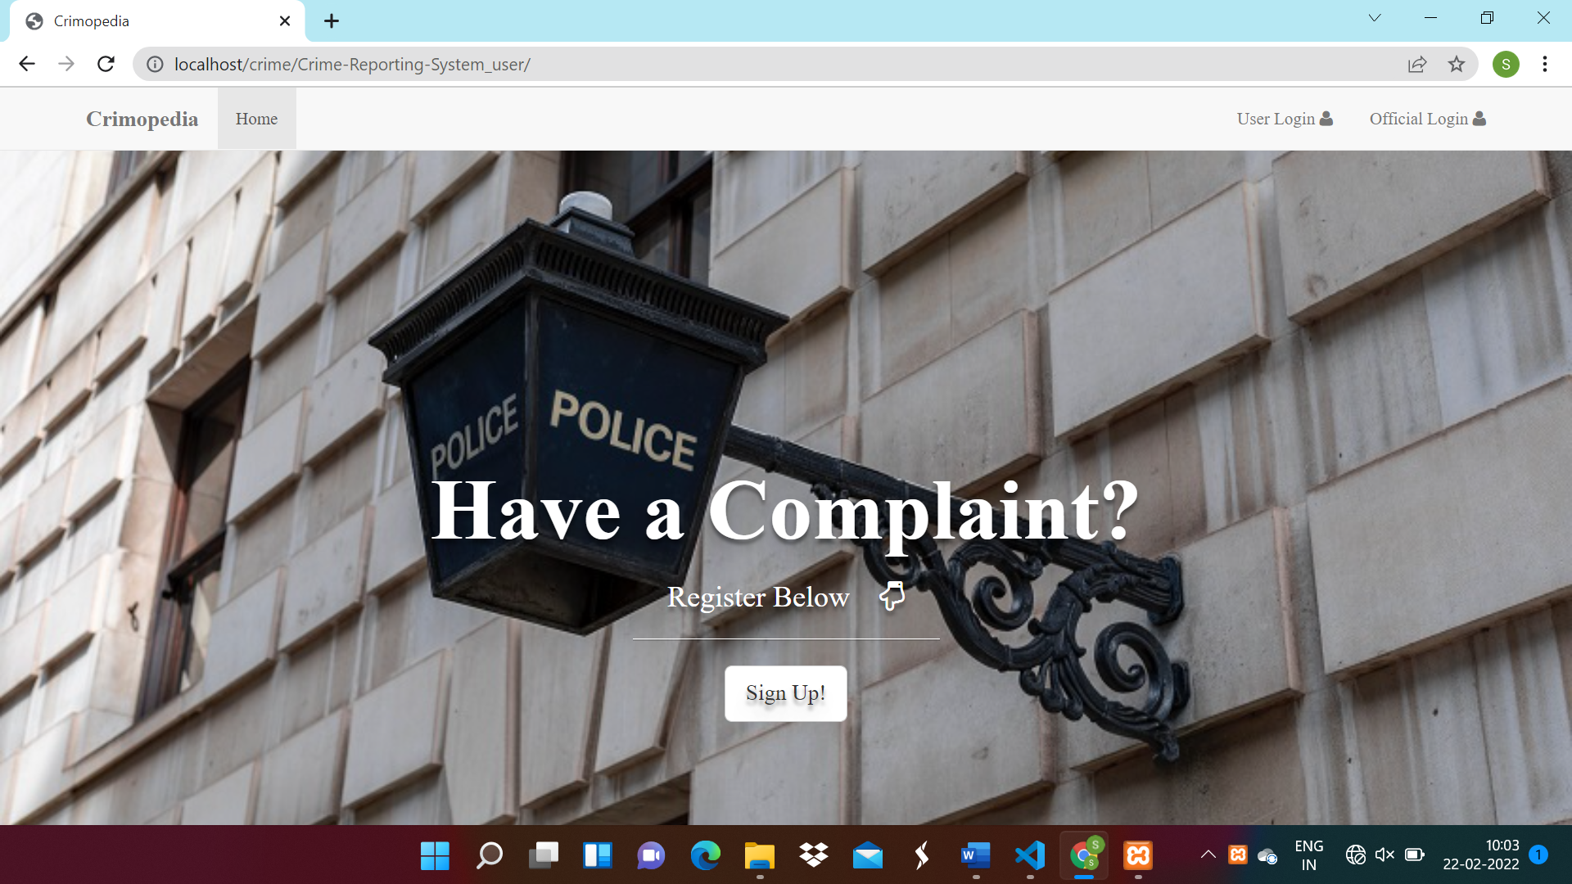

**Complaint registration**

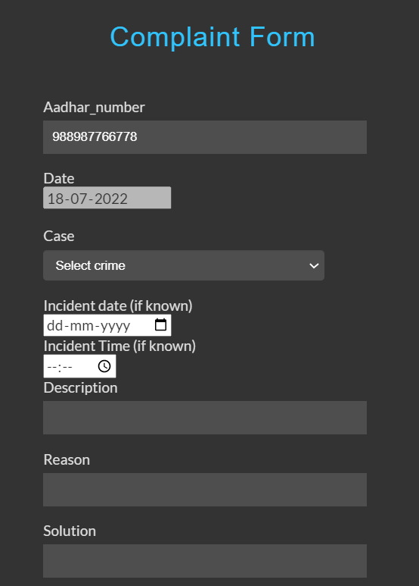

**Fir Information Report**

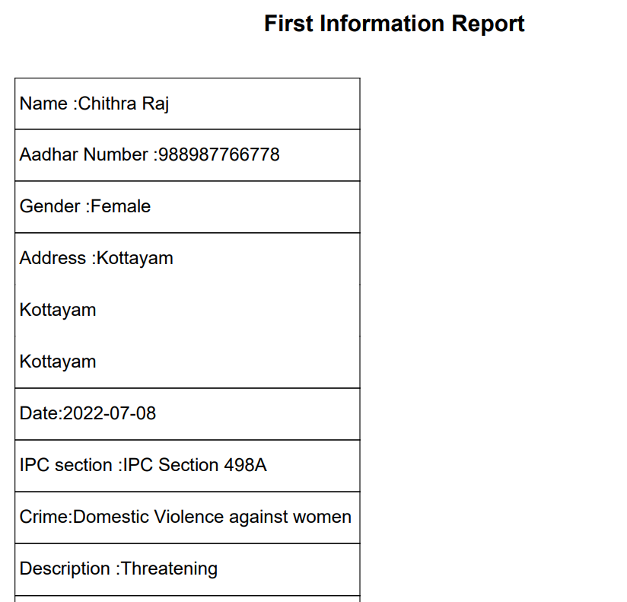

**Lawyer Consultation**

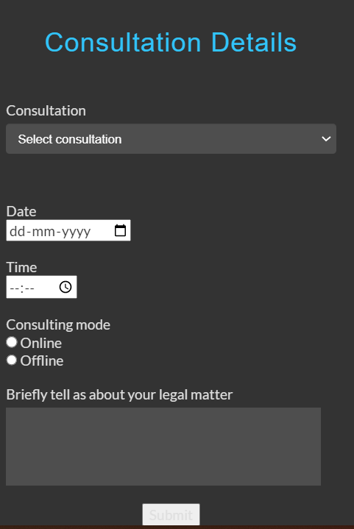

**Police Dashboard**

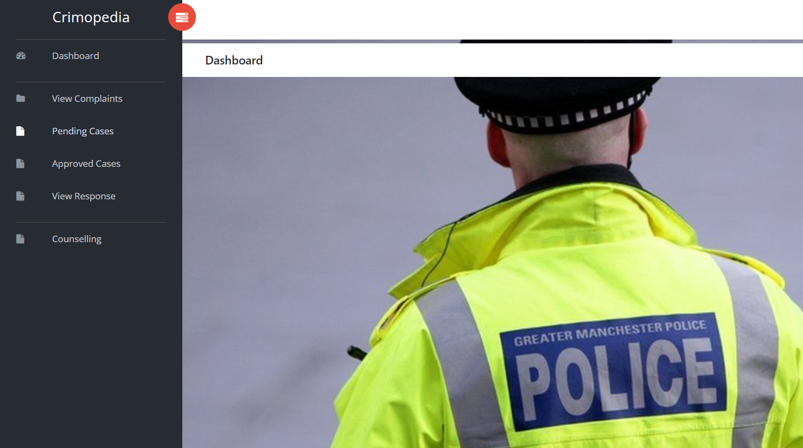

**View complaints**

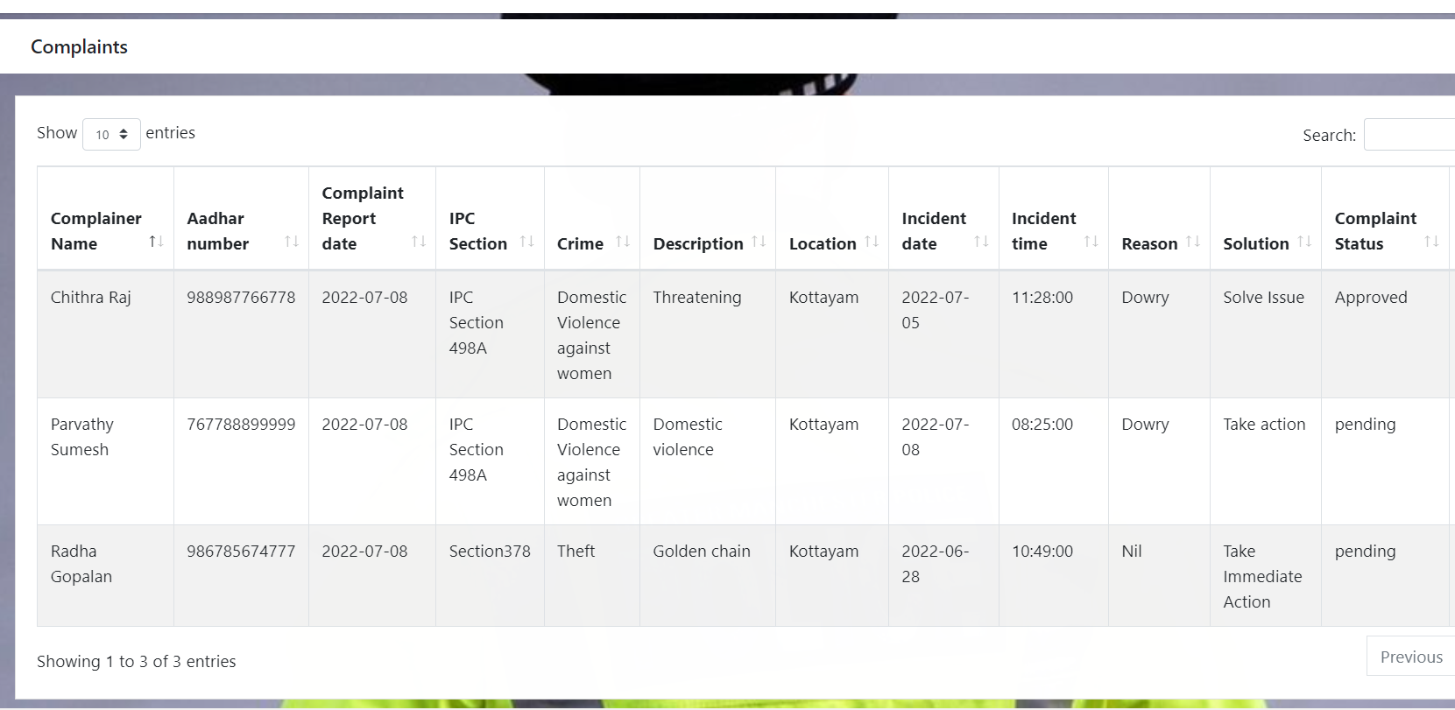

Approved cases

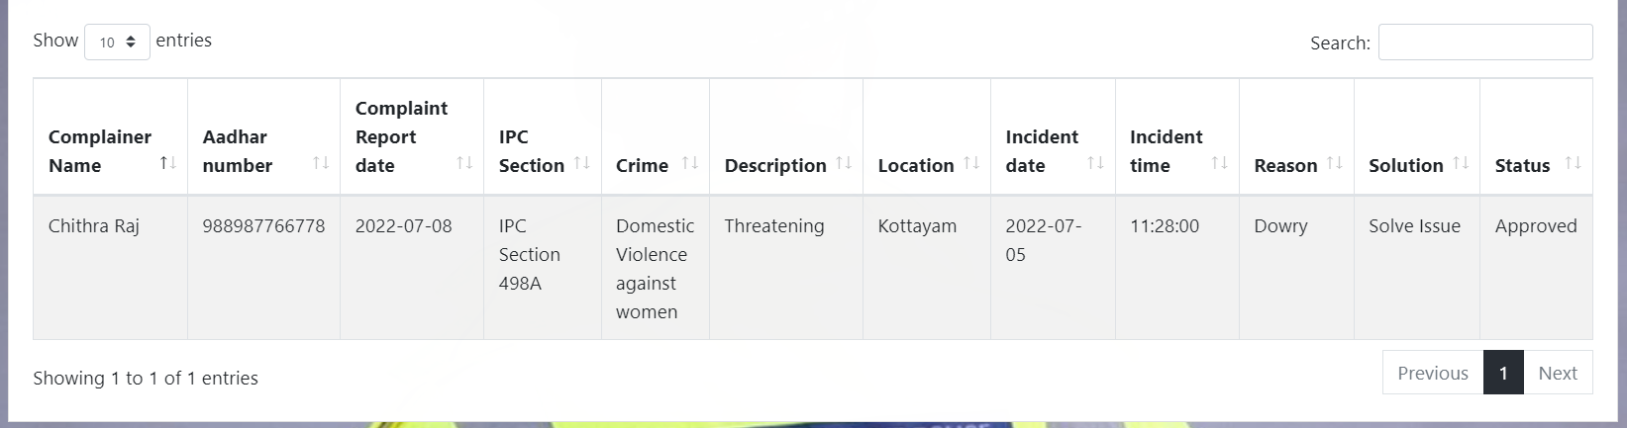

**Request counselling**

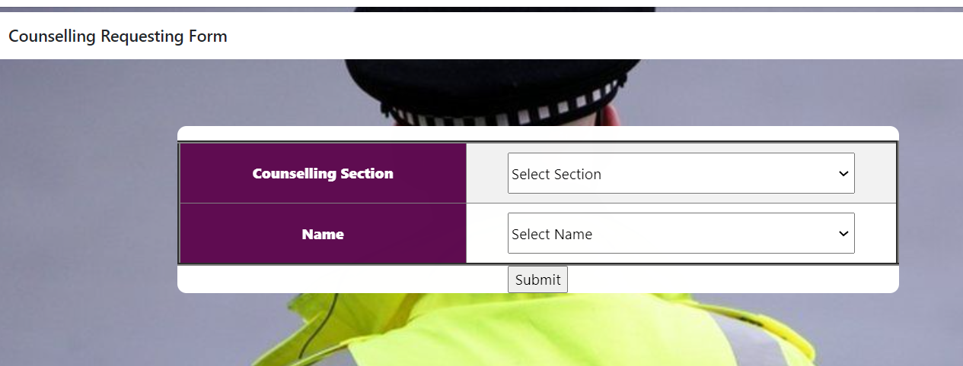

**Schedule Counselling**

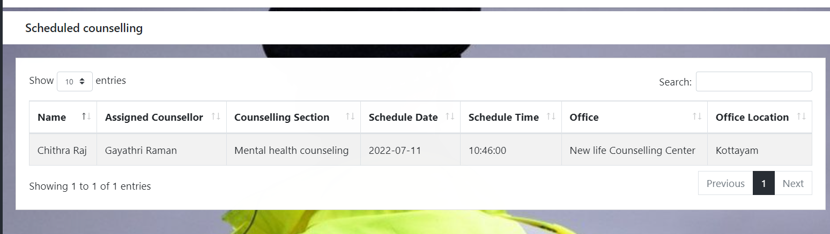

**Counsellor view request**

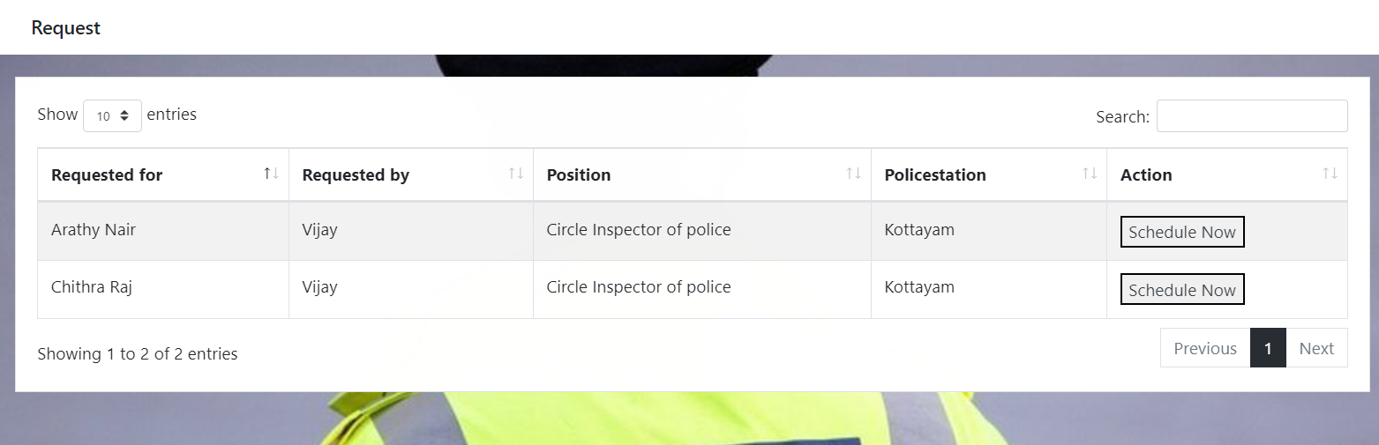

**Counselling Completion Certificate**



**payment**

